Table of Contents

1 Abstract 1

2 Zusammenfassung 1

3 Introduction 2

4 Background 3

4.1 Forests on peatlands 3

4.1.1 Peatland 3

4.1.2 Classification of peatlands 3

4.1.3 Forest Peatlands 5

4.1.4 Forestry and drainage of peatlands 5

4.1.5 Importance and restoration of peatlands 7

4.2 Forest growth assessments 9

4.3 Forest Structure 10

5 Methods 13

5.1 Study area 13

5.2 Plot and study design 15

5.3 Data sampling 16

5.4 Calculations 18

5.4.1 Biomass volume 18

5.4.2 Forest yield classes 23

5.4.3 Forest Structural Index 23

5.5 Statistics and analysis 25

6 Results 27

7 Discussion 36

8 Conclusion 37

9 References III

Figures XIV

Figures (Appendix) XIV

Tables XVI

Tables (Appendix) XVI

Appendix XVIII

A.1 Sampling plots XVIII

A.2 Yield class graphics XX

A.3 Plots’ results XXII

# Abstract

# Zusammenfassung

# Introduction

# Background

## Forests on peatlands

### Peatland

Peatlands are special terrestrial and wet ecosystems which developed under waterlogged conditions. The absence of air and thus oxygen prevents dead organic matter (e.g. litter or dead roots) on or below the surface from rotting and eventually to be decomposed by microorganisms in the soil (Joosten and Clarke 2002). Instead, the anaerobic environment leads to the development of peat – a type of soil with an organic material content of more than 30 % (AG Boden 2005). In contrast to other water-influenced terrestrial ecosystems (e.g. swamps, riparian forests or marshlands), natural peatlands, also referred to as mires, do not completely dry out periodically which avoids the decomposition of peat (DWS 2022). This provides an ideal environment for the sustainable accumulation of peat to build up the characteristic peat horizon with a thickness of more than 30 cm (AG Boden 2005). Still, the water level oscillates but does not dropmore than 10 cm below the peat surface (Aerts and Ludwig 1997). Due to large pores within the peat and floating vegetation the peat body can absorb and release water by swelling and shrinking (Joosten 1993). This makes the peatland a self-regulating ecosystem and enables it to adapt to altering water availability. With these special properties, peatlands represent an own soil class in addition to terrestrial, semi-terrestrial, sub-hydric and semi-sub-hydric as well as salt and sodic soils (Blum 2020).

### Classification of peatlands

One peatland is not like another. The development of peatlands is depending on different factors like the climate situation (e.g. the ratio of precipitation and transpiration or the duration and depth of soil frost), the geological characteristics of the subsoil (e.g. water holding capacity), the surrounding environment and the conditions of water source and runoff (e.g. its size, relief, substrate, plant cover and use of the catchment area) (Xintu 2009; Succow and Jeschke 2022). They can be classified into 2 main types (bogs and fens) and various sub and intermediate types of peatlands which are defined either by their ecology (water/soil trophy and their occurring plant communities) or their hydrology (origin of water and its movement).

Raised bogs are ombrogenous or ombrothrophic peatlands which are fed only by precipitation. They are situated on top of the bedrock without any access to groundwater or other surface water bodies (Burmeister et al. 1990). Subsequently, they are depending on frequent precipitation and lower rates of water extraction by percolation, runoff and transpiration to keep a constant water level (Johnson 1985). Since bogs exclusively receive their water from precipitation, they are rather poor in nutrients which also limits the diversity and amount of vegetation. It mainly consists of sphagnum mosses besides some dwarf shrubs (e.g. heaths), cranberry and thin-leaved sedges (Kaule 1973; Burmeister et al. 1990). Sphagnum mosses are the main driver for peat production in bogs. While the moss is constantly growing upwards, its lower part dies. Due to the lack of nutrients and water movement in bogs, the pH-value and oxygen concentration of the water is rather low (Clymo 1984) which gives them an acidic character and reduces the activity of microorganisms. This leads to a reduced turnover of the dead organic material. Instead, the organic material accumulates as peat which piles up on top of the bedrock in a convex bulged peat body and causes the ground to grow upwards (Eggelsmann 1990a).

On the contrary, fens are emerging from ground or accumulated surface water and can be found in depressions or lower positions where water is naturally accumulated (Burmeister et al. 1990). Due to their independence from precipitation, fens can also occur in drier regions with less precipitation (e.g. Brandenburg). Unlike bogs, fens do not pile up peat. Instead, the dead organic material is sinking to the ground of the water body which successively leads to accumulation of peat below the water surface (Pickert and Bräutigam 2017). Fens are minerotrophic wetlands and thus can be rich in nutrients depending on the amount of dissolved nutrients in the water which are originating from the bedrock underneath or around the fen’s water catchment area. This and the slight movement of water often leads to a less acidic environment compared to bogs and is favorable for a more diverse society of plant species including various grass species e.g. reeds or sedges and even natural wetland forest species mainly consisting of alder trees (Johansen et al. 2018; Schrautzer and Trepel 2014; Burmeister et al. 1990). Furthermore, the moving water in fens is causing a higher oxygen concentration which enhances the activity of decomposers and thus leads to a smaller accumulation of peat.

When environmental conditions change, the peatland type might change as well. This way, a former minerotrophic fen which is increasingly affected by precipitation water and thus can be characterized as ombrominerotrophic, is called a transitional bog (Burmeister et al. 1990). On the other side, when fens dry out, the peat gets in contact with oxygen and the microorganisms will start to decompose it. Then the peatland can turn into gley soils (Sauerbrey et al. 2002) which dry out from time to time .

### Forest Peatlands

According to Hasch et al. (2007) forest peatlands comprise all woody-stocked or non-stocked mires with forest connection. Hereby, the water balance of the peatland system is primarily characterized by a forested catchment area. Natural peatland forests are developing under special circumstances where nutrient contents are rather low and the water availability usually exceeds the upper tolerance limits of most tree species. While fens often show a higher diversity of plant species where even alder swamp forests can naturally arise, the core zone of raised bogs is usually free of larger forest species like trees. Only in the drier parts at the edge of the bog, species like birch (*Betula pubescens*) and pine trees (*Pinus mugo*) (or spruce [Picea abies] on higher elevation) may be able to establish simple forest structures with low growth rates of up to 3 m3 ha-1 a-1 (Stegink-Hindriks 2022).

In contrast to this, forested peatlands are man-made forest plantation on degraded and drained peatland sites. The afforestation with non-side adapted tree species like pine (*Pinus sylvestris)*, oak (*Quercus robur*) or beach (*Fagus sylvatica*) often takes place after intensive site preparations (e.g. plowing or fertilization) to create more productive forests with doubled yields (Stegink-Hindriks 2022).

### Forestry and drainage of peatlands

Ever since peatlands started to develop after the last ice age about 10,000 years ago (NABU 2023), they did not play a major role in people’s life. Mires have primarily been seen as mystical places and were only faced in myths and stories. The low productivity as well as the impossibility of peatlands to be used for transportation by terrestrial or aquatic vehicles prevented any human interest in peatlands for agriculture, forestry or construction (Eggelsmann 1990a).

In the 18th century, peatlands started to become more important in Germany and central Europe when people recognized the economic potential of drained peatlands which can provide an additional source of cultivable land for agriculture or forestry and peat to be used as fuel or fertilizer (Müller-Kroehling and Zollner 2015). Since then, the intensity of usage and exploitation has strongly increased. By now, more than 90 % of all peatlands in Europe (Bonn et al. 2015) and 95 % in Germany are drained and ameliorated (Succow and Jeschke 2022).

Several studies show that the drainage of peatlands has even more severe effects on the ecosystems themselves and their coupled systems and processes (Eggelsmann and Mäkelä 1964; Höper 2007; Müller-Kroehling and Zollner 2015; Ramchunder et al. 2009; Roulet and Moore 1995; Succow and Jeschke 2022). The water that got drained gets lost from the ecosystem and cannot be provided anymore for the vegetation close by. Without the water, the peat which has not gotten harvested yet for fuel or fertilizers starts to mineralize through the contact with oxygen. Instead of sequestrating carbon from the atmosphere, peatlands turn into new carbon sources when the carbon stored in the peat body is decomposed by microorganisms and released as carbon dioxide or methane. Hutchinson (1980) found that the mineralization of the peat also leads to unequal shrinking of the peatland body’s surface, sometimes even by several meters due to a heterogenous thickness of peat throughout the peatland area. This creates micro reliefs on the peatland surface and the peat body ultimately loses its ability to expand when the water level rises again. With the shrinking of the peatland body, the peatland surface gets lowered and the ground becomes unstable. Besides the instability, the ground water level has changed as well and requires constant drainage and adaptation to avoid waterlogging conditions and ground water impact on the site. The loss of water causes the release of stored nitrogen on alkaline fen sites which leads to an over-eutrophication of the peatland surface and the ground water. On nutrient-poor bog sites, the lack of water increases the mobility of phosphor.

Furthermore the drainage of peatlands increases its predisposition towards natural damages by erosion (IUCN Peatland Programme 2023; Li et al. 2018) or even wildfires due to the fuel character of dry peat (BMUV 2022). To avoid the erosion and desertification effects after drainage, the state-owned forest offices were directed to afforest degraded peatland sites (Stegink-Hindriks 2022). Nowadays, about 15 % of the 1.8 million hectares of peatland in Germany are classified as forest or forested peatlands (BMUV 2022). In the German state of Bavaria, forest peatlands represent even 30 % of all peatlands (Müller-Kroehling et al. 2023). Due to the increasing demand for natural resources like wood in Germany, forested peatlands are still frequently used but after centuries of intensive peatland exploitation, forest policy is looking for new low-impact and close-to-nature approaches to manage forest peatlands. Extensive management practices in peatland forests involve the strategic use of selective tree harvests, particularly employing group felling of a few large trees within the predominantly spruce stands on frozen ground Wende and Schlenz (2017). This method aims to enhance the regeneration of mixed tree species by allowing increased light penetration through the opening of the crown canopy into the understory. The harvested logs are extracted by mechanized cable winches minimizing ground disturbance and major damages to the peatland ecosystem.

### Importance and restoration of peatlands

Peatlands are the most effective systems when it comes to carbon storage. They are covering less than 3 % of the world’s total terrestrial area (Xu et al. 2018) while storing more than half a trillion tons of carbon (Yu et al. 2010; IUCN UK 2020). This easily exceed the amount of carbon that is stored by all the forests biomass together (Pan et al. 2011). Regarding the production of biomass, peatlands show a comparable productivity as forests in Germany do. Succow and Jeschke (2022) found that bogs, which are solely fed by less nutritious precipitation are producing a biomass of up to 8 t ha-1 a-1 and more nutrient-rich fens can achieve twice the amount within one year. Natural peatlands have an increment of 5 – 15 m3 ha-1 a-1 of peat while they are losing 50 – 250 m3 ha-1 a-1 organic material once they are drained. Meanwhile, the National Forest Inventory shows that forests in Germany, depending on the tree species and their site conditions, are growing by 11.23 m3 ha-1 a-1 on average (Thünen-Institut 2012). The carbon of dead organic biomass from the plants gets preserved within the peat for thousands of years thus it is disposed permanently from the atmosphere until being disturbed (Göttlich 1990). For forests these periods of carbon storage are shorter and usually limited to where the biomass is either harvested or the tree dies and the carbon is released again by burning or decomposition. Besides carbon, the peat also absorbs other elements like nitrogen and phosphor (Göttlich 1990).

Additionally, peatlands are important providers of water to the surrounding landscapes. Due to their water content of up to 95 % (Eggelsmann 1990a; Succow and Jeschke 2022) and the oscillation properties of their peat bodies, these wetlands can help to compensate extreme weather events like buffering excess water during heavy rain and floods or provide humidity and cooling through surface transpiration during droughts and heat periods (Müller-Kroehling and Zollner 2015). The rather nutrient-poor environment of peatlands is furthermore dependent on external nutrient input. Subsequently, it filters all substances from the water including pollutions (Göttlich 1990).

In the 1960s, renaturation measures of peatlands have taken place as a first attempt of biodiversity conservation in peatland areas. About one decade later, also the rewatering of peatlands have been taken into consideration for the first time while the mitigation of climate change effects were progressively coming into the focus of the general public and politics (Müller-Kroehling and Zollner 2015; Rattay et al. 2016).

The restoration of peatlands mainly concludes the process of rewatering, renaturation and regeneration (Eggelsmann 1990b). The rewatering of the peatland is achieved by closing former draining diches to prevent any further drainage of the peatland area (Zollner 1993). Then the peatland area can be flooded again by the water catchment area or precipitation. As a support for the rewetting, silvicultural measures, e.g. thinning of the occurring forest stand, can be applied (Zollner 1993; Zollner and Cronauer 1998). This will increase the water supply from stand precipitation which reaches the ground due to reduced interception effects from the trees. The lower vegetation cover also minimizes the water uptake by wooden species. Additionally, thinning of the forest stand and rewatering of the area support the renaturation of the peatland as well. The lower stocking level of former economic tree species reduces the degree of ground shading and enhances the potential for natural peatland and pioneer species to establish a peatland forest under close-to-nature conditions again (Zollner 1993). In a last step, the water level needs to be raised until a minimum soil depth of 10 cm below the peat body surface (Müller-Kroehling and Zollner 2015) so the peat regeneration sets in and the peatland can be fully revived again (Eggelsmann 1990b).

Yet, restored peatlands will still differ from natural peatlands. Due to the uneven relief coming from the surface shrinking of the drained peat body, the restored peatland cannot be equally rewetted again (Zollner 1993). Some parts of the original peatland area will stay dry which changes the character of the ecosystem. This divers mosaic of microhabitats gives the chance to be used as refuges by species which were better adapted to the former dry conditions of the drained peatland (Müller-Kroehling and Zollner 2015).

In order to fully recover and regain its natural conditions, the rewatered peatland needs to face a long-term succession (Succow and Jeschke 2022). Nowadays, this has become more challenging because of the very intensive usage and altered climatic conditions. The drained peatlands have developed from originally rather nutrient-poor ecosystems into more eutrophic ones because of the employment of fertilizers on forested peatlands (Grützmacher and Schulte-Eickholt 2017). The enriched nitrogen combined with lower humus contents have a negative impact on the percolation and water flow rates from the water catchment areas towards the peatlands. At the same time, precipitation rates are decreasing which puts the adequate water supply for peatland development at risk. Lastly, the increased nitrogen contents in the ground water and raising mean temperature leads to higher turnover rates of organic biomass which impedes the development of peat (Succow and Jeschke 2022).

## Forest growth assessments

Growth is a basic process of all natural organisms. In forests it applies as the increase of dimensions (diameter, basal area or height) of forest vegetation and the single tree compartments (roots, stem, branches, leaves and needles). Forest growth is a dynamic process influenced by various factors, including climate, soil quality, species composition, management practices and stand age (REFERENCE). Effective management requires an understanding of forest growth, the factors influencing its development and the maximum sustainable yield that can be extracted. Forest growth assessments are therefore essential measures to determine its health and the productivity per area and time unit for forest management (Kramer and Akça 2002). Hereby, different terms indicate different measures which should be clearly separated.

Forest increment refers to the increase in dimension of one individual or a group of trees over a given period of time (Gadow 2003). Commonly, it is expressed as an annual increment. The mean annual volume increment is defined as the sum of several annual increments divided by the number of years (van Laar and Akça 2007). Forest yield furthermore indicates the final dimensions at a certain age of the forest stand. It is therefore used as a measure to determine the optimal harvest moment and the maximum harvestable quantity accumulative increment (expressed in biomass volume or mass per area unit) to be extracted in a sustainable manner.

Tree species-specific growth and yield information are listed in yield tables. These tables are based on extensive empirical data samplings of tree volumes and single tree growth modelling (Albert et al. 2021) and are developed for pure monocultures of particular tree species separated by site, forest management intensity and stand density. Yield classes (EKL – German: Ertragsklasse) are stating the harvestable biomass volume per unit area (usually 1 hectare), the mean tree height or mean diameter at the age 100. The yield class of a forest stand is determined by the relationship between forest stand age and its average growth parameters (tree height, breast-height-diameter or stand coarse wood volume per hectare).

## Forest Structure

The structure of forests refers to its physical organization, encompassing the vertical and horizontal distribution of vegetation, the dimension and age of trees and the presence of distinct forest layers. Forest structure shapes the conditional environment, including light availability, air and soil temperature and moisture content, which in turn affects the composition of species within the forest by providing niches for special-needs species. The layers of a forest, from the towering canopy to the diverse understory and the forest floor, each provide unique microhabitats that cater to different plant and animal species. Forest structure, therefore, plays a pivotal role in determining the abundance, distribution, and interactions of these species. Sabatini et al. (2015) and Storch et al. (2018) collected a variety of useful aspects of forest structure which have a direct impact on biodiversity, forest services and functions and its future development.

Forests are ecosystems based on high-growing trees. The tree heights as their main unique attribute compared to other ecosystems is a first important aspect of forest structure. The vertical heterogeneity caused by a broader range of tree heights within a forest stand may result from a higher variety of tree ages as they usually do not appear within even-aged plantation forests. Thus, it can be an indicator for highly structured and uneven-aged old-growth or close-to-nature forest management (Burrascano et al. 2013). Natural resources such as light or precipitation are distributed differently to the single vegetation layers (Matsuo et al. 2022). Subsequently, a higher variety of forest strata can provide diverse environments and conditions (e.g. wind protection, cover or food) for special plant and animal organisms’ needs (Keeton 2006; Martins et al. 2017). Furthermore, the ability to establish an understory layer and ground vegetation within forest is adding other unique niches for potential forest specialists (Hao et al. 2007; Hatanaka et al. 2011).

Many studies consider a high species richness, specifically of broadleaved tree species, as an important measure to increase a forests structural diversity (Juchheim et al. 2019). Compositional species diversity though, does not only describe the richness in plant taxa which can stand in competition for nutrients, water and light but also supplementary compositions of species to either build symbiotic relationships or to complement functional gaps within the ecosystem. The mixture of opposite species couples such as shade-tolerant and light-demanding, shallow and deep-rooting or conifer and broadleaved species can optimize the spatial utilization of stocked area and niches, the proper distribution of scarce resources and the resilience of the entire forest ecosystem. Additionally, various physical and chemical attributes like light-transmittance of the canopy or litter quality are highly depending on the combination of tree species (Barbier et al. 2008). Besides serving as a seed source to the future forest regeneration, the choice of tree species composition also determines the appearance of ground vegetation and understory (Barbier et al. 2008; Barbier et al. 2009; Burrascano et al. 2011).

Accumulated biomass is another forest structural factor which affects the performance of ecosystem services, biodiversity and forest stability. High growing stocks contain lots of stored carbon sequestrated from the atmosphere (Hoover et al. 2012; Houghton 2005; Gilhen-Baker et al. 2022) and water to keep up the more humid microclimate with moderate temperatures (Norris et al. 2012) which also supports the ecosystem to face the disturbances and climate change (Ali and Wang 2021). This particularly applies to forests with a high proportion of old trees with larger diameters as they store carbon more efficiently (Stephenson et al. 2014). Furthermore, large trees are very valuable as micro-habitats because they provide a vast variety of species niches (e.g. tree caves, rough bark or dead wood compartments) for fungi, lichen, insects and smaller vertebrates (Bütler et al. 2013). All these effects can be well-observed in old-growth forest compared to secondary forests since they usually are able to outcompete even major secondary-growth forests in both high biomass stocks and the abundance of large-living trees (Hoover et al. 2012; Brunialti et al. 2010).

Lastly, deadwood biomass in the forest also displays a structural indicator for forest functionality and diversity. Just like their living counterparts, standing dead trunks and snags provide diverse habitat niches and food for rare species such as saproxylic fungi and insect species (Persiani et al. 2010; Lassauce et al. 2011) but also many mammals and birds are using hollow or piled up woody structures for shelter. While coarse woody debris of any kind is important, big standing logs are playing a special role due to their long existence and slow decomposition rate compared to smaller pieces lying on the forest ground (Gärtner et al. 2023). Besides the biodiversity aspects, deadwood is a key element within ecosystem cycles and processes. The additional biomass stores water and serves as a cooling factor for its environment. Through its decomposition, the nutrients which were taken up by the former tree and are now stored in its biomass, can be recycled back into the ecosystem to become available for new tree growth and hence enriches the quality of the site (Prescott 2002; Weis et al. 2016). In general, dead wood accumulation is an indicator for close-to-nature conditions within a forest (Castagneri et al. 2010) since intensively managed forest are often fully cleared of woody biomass because of wildfire fuel reduction but also economic purposes (Weis et al. 2016). Thus, managed forests had no chance to accumulate dead wood on a higher scale. This especially becomes visible when deadwood decay classes are missing within a forest stand. The absence of certain classes usually indicates the extraction of deadwood which leads to a disturbance in the continuous addition of new deadwood and the succession of decomposition (Lombardi et al. 2011).

# Methods

## Study area

Since being conducted as a part of the Peatland Monitoring Program for Climate Protection – Forest (German: Moorbodenmonitoring für den Klimaschutz - Wald [MoMoK-Wald]), this study is based on the data obtained from the 50 defined monitoring sites of the MoMoK-Wald project. By the time of writing this master thesis (November 2023), the data collection has taken place on 34 of these monitoring sites (Fig. 1), thus, only the results of this limited number of plots are part of the scope and can be considered in the analysis of this study.

The monitoring sites are distributed across Germany throughout the federal states of Schleswig-Holstein (n = 2), Lower Saxony (n = 6), Mecklenburg-Western Pomerania (n = 4), North Rhine Westphalia (n = 1), Saxony Anhalt (n = 1), Brandenburg (n = 6), Rhineland-Palatinate (n = 2), Hesse (n = 3), Thuringia (n = 2), Saxony (n = 4), Baden-Württemberg (n = 1) and Bavaria (n = 2). Each site is then categorized by its peatland type, the forest stand’s main tree species and the hydrological status of the peatland. The MoMoK-Wald project defined the peatland types on the sampling sites by their ecological classification according to the pedological soil identification guideline KA5 (AG Boden 2005). For this thesis bogs (n = 10), fens (n = 21) and gley soils (n = 3) are differentiated. Transition bogs are treated as normal bogs. For the MoMoK-Wald project only peatland sites are selected which indicate a homogenous forest stand (main tree species share of > 80 %) and the main tree species being European black alder (*Alnus glutinosa [L.] GAERTN.* [n = 13]), Downy birch (*Betula pubescens EHRH.* [n = 7]), Norway spruce (*Picea abies [L.] H. KARST.* [n = 8]) or Mountain pine (*Pinus mugo TURRA* [n = 6*]*). Pine trees of Mountain pine plots have sometimes been identified as Scots pine (*Pinus sylvestris* *[L.]).* The hydrological status is differentiated between drained (n = 19) and normal (n = 15) peatlands. The drained sites also include peatlands which are partially drained and the normal sites summarize all peatlands which are either close to nature (non-drained), very slightly drained or even rewetted.



Fig. 1 – Monitoring sites across Germany. The Map was created in QGIS (QGIS Development Team (QGIS Development Team 2023)) using open source data from GADM (2022) and UN WFP (2019)

## Plot and study design

The plot design and data sampling methodology are based on the sampling and analysis manual for the MoMoK-Wald project (Gabriel et al. 2021).

On each monitoring site, a 0.25 ha square sampling plot with a side length of 50.00 m is installed in reference to a previously defined GPS point. From this reference point, the plot’s center point and all 4 plot corners of the sampling plot are placed as boundaries and described by their polar coordinates. The plot’s center point and corners are marked with wooden sticks for visual identification. The sampling plot consists of several single sub-plots to assess the different parameters of interest.

A verbal forest stand description is conducted throughout the entire square sampling plot (Fig. 2). In a circular plot with a radius of r = 12.62 m around the main plot center, every tree and its growth and vitality parameters are recorded. Additionally, standing and downed deadwood is sampled and measured within the same circular plot. The location of the main plot center is selected in a way that the heterogeneity of the site is optimally represented by the sample plot. For the regeneration survey, 4 circular satellite plots are established with a distance of 10 m in all 4 main geographic directions from the main plot center. Each of the satellite plots has a radius of r = 5.00 m around their plot center. Additionally, a vegetation survey is conducted on 4 randomly distributed 100 m2 (Σ 400 m2) sub-plots within a 30 m radius around the main plot center.

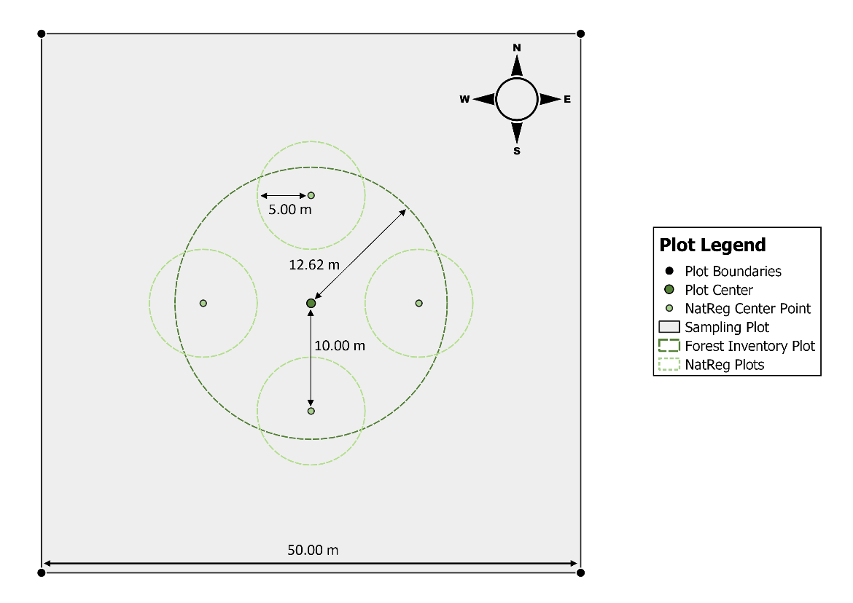

Fig. 2 – Plot design: Squared sampling plot (edge length: 50.00 m) with a circular forest inventory plot (radius: 12.62 m) and 4 satellite circular plots for the natural regeneration survey (radius: 5.00 m)

## Data sampling

The polar coordinates are derived from distance and azimuth measurements between the plot center point and the plot corners or satellite points by using a Vertex device (Haglöf 2023) and a compass.

For all trees within the main circular plot (A = 500.34 m2) and which are classified as merchantable wood and thus, have a breast height diameter DBH ≥ 7 cm, the growth and vitality parameters are recorded. This includes the identification of tree species, the polar coordinates in relation to the center point, the measurement of the DBH with a girth tape and an estimation of the Kraft’s class for all trees. The tree height and crown base height are only measured for a minimum of 5 trees per site but covering all occurring DBH classes. It was measured by using a Vertex device. Lastly, the tree or forest stand age is derived from various sources (Tab. 1).

Tab. 1 – Age determination (Wellbrock et al. 2022)

| Code | Type | Method |
| --- | --- | --- |
| 1 | FE | forest inventory |
| 2 | whorl | counting of branch whorls (only conifers) |
| 3 | tree stumps | counting of growth rings on tree stumps |
| 4 | growth rings | counting of growth rings on borer cores |
| 5 | estimation | estimation |
| 6 | PC | preliminary clarification by forestry companies |

The deadwood survey is carried out on the main circular plot (A = 500.34 m2) as well. The measurements of the deadwood’s length or diameter are done according to its classification (Tab. 2) and only when the minimum criteria for a deadwood type is met. Here all parts of the deadwood pieces are included which are lying within the 12.62 m radius, even when its origin was rooted outside of the circle. Outlying parts of included pieces are cut off.

For downed deadwood (1), length of the trunk or branch and its center diameter (diameter at the half of its length) is measured. Standing dead trees (2) and snags (3) are recorded by their DBH and the height of their trunk. When measuring tree stumps (4), the height of the stump and the average diameter at the cutting surface (aDSC) need to be assessed. For completely downed trees (5) the length of the trunk is measured as well as the DBH. In the case of deadwood, which was piled up (6), the average center diameter of the single pieces is determined and their length is estimated. In the end, the degree of decay (Tab. 3) must be determined for all deadwood pieces.

Tab. 2 – Deadwood types (Wellbrock et al. 2022)

| Code | Deadwood type | Criteria |
| --- | --- | --- |
| 1 | downed deadwood, branches, twigs, crowns | diameter ≥ 10 cm at the thicker end |
| 2 | standing tree | DBH ≥ 10 cm, with branches |
| 3 | snag | DBH ≥ 10 cm, height ≥ 130 cm, without branches |
| 4 | stump | aDCS ≥ 10 cm, height < 130 cm |
| 5 | downed tree | DBH ≥ 10 cm |
| 6 | piled deadwood | diameter ≥ 10 cm at the thicker end |

Tab. 3 – Degree of decay (Wellbrock et al. 2022)

| Code | Degree of decay |
| --- | --- |
| 1 | no decay |
| 2 | solid wood, 10 % altered wood structure, low infestation of wood-decomposing organisms, no limbs < 3 cm |
| 3 | slight decay, 10-25 % altered wood structure, easy insertion with a sharp tool |
| 4 | medium decay, 26-75 % of the wood is soft to very soft; or friable, original cross section of the wood might have altered |
| 5 | strong decay, 76-100% of the wood is soft, original cross section of the wood has altered |

The regeneration survey is conducted in 4 circular sub-plots (A = 314 m2) located at the satellite points around the main plot center. Here, the 10 trees which are closest to the sub-plot center point are recorded but not further than 5 m away from the center. Only those trees are considered in the survey which exceed the minimum height of 2 dm but are not part of the forest inventory (DBH < 7 cm). If there are more than 10 trees within the given radius, the distance of the 10th farthest tree is measured as well as the height of all recorded trees. Furthermore, the tree species is identified.

In the vegetation survey, an estimated degree of ground cover is recorded for every plant species separated by forest strata (Tab. 4) and subplot. The obtained data is then merged for one total vegetation plot of 400 m2 by building the mean value of the ground cover degree for all plots.

Tab. 4 – forest strata (Wellbrock et al. 2022)

| Strata | Description |
| --- | --- |
| Tree 1 | all wooden and climbing plant species of the main stand |
| Tree 2 | all wooden and climbing plant species above 5.0 m height but not being part of the dominating main stand |
| Shrub | all wooden and climbing plant species (≥ 0.5 m and < 5.0 m height) |
| Herb | all grass and herbal plant species without height limitation as well as wooden and climbing plant species below 0.5 m height |
| Moss | all epigeic and epilithic moss and lichen species |

Tab. 5 lists up the measurement equipment and its usage for the data collection as well as the software used for data analysis.

Tab. 5 – Measurement tools and analysis software

| Tool | Usage | Resolution | Precision error |
| --- | --- | --- | --- |
| Haglöf Vertex V* | distances | 0.01 m | ± 0.0001 m (1 %) |
| height (by distance and 2 angles) | 0.1 m | ± 0.001 m (1 %) |
| compass | azimuth | 1.0 gon | ± 0.01 gon (1 %) |
| girth tape | breast height diameter | 0.1 cm | ± 0.001 cm (1 %) |
| measuring tape | length of downed deadwood | 0.1 cm | ± 0.001 cm (1 %) |
| tree caliper | diameter deadwood | 0.1 cm | ± 0.001 cm (1 %) |
| meter stick | height of tree stools and natural regeneration | 0.1 cm | ± 0.001 cm (1 %) |
| Quantum GIS V.3.30.3 | GIS and mapping |  |  |
| RStudio V. 2023.06.0 | statistics and plotting |  |  |

* source: Haglöf 2023

## Calculations

### Biomass volume

The biomass volume of a tree is highly related to its diameter and height, thus, the volume is commonly calculated through different volume functions using one or even both variables as an input. To estimate the biomass volume per hectare, it usually only requires the basal area of the sample plot and the average tree height which is representative for the entire forest stand. A more precise approach is to collect the information about the DBH and the height of every single tree on the plot that has been recorded during the data sampling process and then calculating the volume of each single tree. Afterwards the accumulated biomass of the entire sample plot can be extrapolated for the area of one hectare. Since only the heights of 5 to 10 trees, covering all DBH classes, have been sampled according to the methodology, the missing height must be estimated.

For the estimation of the missing tree heights hp, a self-fitted non-linear least squares (NLS) model is conducted by using the relation between DBH and tree height in the equation 1 (Braga et al. 2023b)

|  |  |
| --- | --- |
|  | 1 |

and the forestmangr::nls_table command (Braga et al. 2023a) to predict the fitting parameters b0 to b2. The NLS model is applied separately for each species and plot when there are at least 3 height measurements per tree species and plot available. Furthermore, the coefficient of determination R2 for the NLS model must exceed a value of 0.7 in order to ensure a sufficient fitting of the model prediction to the entry data. In case, there are less than 3 heights measured for a tree species on a plot or if the R2 value is lower than 0.7, the NLS model is fitted for the heights of each tree species but throughout all plots together.

When there are less than 3 tree heights measured per tree species on all plots together or the R2 value remains below 0.7, the height curve of SLOBODA (Sloboda et al. 1993) is used and hp is calculated with following equation

|  |  |
| --- | --- |
|  | 2 |
|  | 3 |

* BA = basal area

with dg being the diameter and hL Lorey’s height (equation 3) and k0 and k1 being species related curve-fitting coefficients (Tab. 6). Birch and alder trees are assigned to the group of other short-living broadleaved trees (SLB) according to the third National Forest Inventory (Riedel et al. 2017).

Tab. 6 – species related curve-fitting coefficients for SLOBODA height curves (Dahm 2006)

| Tree species group | k0 | k1 |
| --- | --- | --- |
| Spruce | 0.183 | 5.688 |
| Fir | 0.079 | 3.992 |
| Douglas fir | 0.240 | 6.033 |
| Pine | 0.290 | 1.607 |
| Larch | 0.074 | 3.692 |
| Beech | 0.032 | 6.040 |
| Oak | 0.102 | 3.387 |
| LLB* | 0.122 | 5.040 |
| SLB** | 0.032 | 4.240 |

* LLB = long-living broadleaved trees  
** SLB = short-living broadleaved trees

But if there is no information on the required parameters for the height curve of SLOBODA available, the more abstract and less precise approach of CURTIS (Curtis 1967) is used. The function for this height curve (Eq. 4) only requires information about the DBH of the tree to predict its height.

|  |  |
| --- | --- |
|  | 4 |

with b0 to b2 being the fitting coefficients for the CURTIS height curve as stated in Tab. 7. Here all non-listed conifer species are treated as spruce and all non-listed broadleaved species as beech trees (e.g. alder and birch).

Tab. 7 – Species related curve fitting coefficients for CURTIS height curves

| Tree species group | b0 | b1 | b2 |
| --- | --- | --- | --- |
| Spruce | 434.1235 | -65,586.6915 | 3,074,967.1738 |
| Beech | 382.0202 | -51,800.9382 | 2,374,368.3254 |
| Fir | 453.5538 | -81,132.5221 | 4,285,801.5636 |
| Pine | 359.7162 | -42,967.9947 | 1,763,359.9972 |
| Larch | 421.4473 | -60,241.2948 | 2,895,409.6245 |
| Douglas fir | 481.5531 | -81,754.2523 | 4,193,121.2406 |
| Oak | 348.3262 | -46,547.3645 | 2,119,420.9444 |

Tree biomass is estimated through biomass functions from the German National Forest Inventory. The above-ground biomass AGB function by Kändler and Bosch (2013) is divided into 3 parts. AGB of trees with a DBH ≥ 10 cm is derived from

|  |  |
| --- | --- |
|  | 5 |

with D03 being the diameter of the tree trunk at 30 % of the tree’s height which is modelled by Eq. 6  (Vonderach et al. 2023) and b0–3 and k1,2 being species related coefficients (Tab. 8).

|  |  |
| --- | --- |
|  | 6 |

Spp = species code  
Dm = measurements f diameter along trunk  
Hm = height of measurements along trunk  
Ht = tree height  
inv = indicator of inventory (4 = 3rd National Forest Inventory)  
Hx = height of modelled diameter (Hx = 1/3 * Hm)  
cp = cartesian product

Tab. 8 – Species related coefficients for the above-ground biomass function of trees with a DBH ≥ 10 cm (Kändler and Bosch 2013)

| Tree species group | b0 | b1 | b2 | b3 | k1 | k2 |
| --- | --- | --- | --- | --- | --- | --- |
| Spruce | 0.75285 | 2.84985 | 6.03036 | 0.62188 | 42.0 | 24.0 |
| Pine | 0.33778 | 2.84055 | 6.34964 | 0.62755 | 18.0 | 23.0 |
| Beech | 0.16787 | 6.25452 | 6.64745 | 0.80745 | 11.0 | 18.8 |
| Oak | 0.09428 | 10.26998 | 8.13894 | 0.55845 | 400.0 | 12.1 |
| SLB | 0.27278 | 4.19240 | 5.96298 | 0.81031 | 13.7 | 50.0 |

AGB of large trees with a DBH above a certain species-related threshold value (spruce ≥ 69 cm; pine ≥ 59 cm; beech ≥ 86 cm; oak ≥ 94 cm; SLB ≥ 113 cm) are calculated by

|  |  |
| --- | --- |
|  | 7 |

with Bs being the biomass at the species-related threshold diameter DBHs, the species-related parameters D03s (Eq. 8) and Hs (Eq. 9) at DBHs and the species-related coefficients b0,s,3, c0,1, a and b (Tab. 9).

|  |  |
| --- | --- |
|  | 8 |
|  | 9 |

For trees with a diameter at breast height of < 10 cm but with a tree height h ≥ 1.3 m the above-ground biomass function

|  |  |
| --- | --- |
|  | 10 |

is used with Ds being 10 cm as the maximal diameter within the validation limit of this biomass function and b0,s, 3 being species related coefficients (Tab. 9).

Tab. 9 – Species related coefficients for the above-ground biomass function of trees with a DBH < 10 cm and a height ≥ 1.3 m

| Tree species group | b0 | bs | b3 | c0 | c1 | a | b |
| --- | --- | --- | --- | --- | --- | --- | --- |
| Spruce | 0.41080 | 26.63122 | 0.0136956 | 1.07843 | 0.91204 | 0.27407 | 2.22031 |
| Pine | 0.41080 | 19.99943 | 0.0091576 | 0.89009 | 0.95747 | 0.29722 | 1.98688 |
| Beech | 0.09644 | 33.22328 | 0.0116212 | 0.84014 | 0.98970 | 0.29397 | 1.76894 |
| Oak | 0.09644 | 28.94782 | 0.0150089 | 0.87633 | 0.98279 | 0.31567 | 1.63335 |
| SLB | 0.09644 | 16.86101 | -0.0055086 | 0.86720 | 0.96154 | 0.28064 | 2.40288 |

The AGB of trees with a height < 1.3 m is estimated by following equation

|  |  |
| --- | --- |
|  | 11 |

with tree height as dependent parameter and b0 and b1 as species related coefficients (Tab. 10).

Tab. 10 – Species related coefficients for the above-ground biomass function of trees with a height < 1.3 m

| Tree group | b0 | b1 |
| --- | --- | --- |
| Conifer trees | 0.23059 | 0.04940 |
| Broadleaved trees | 2.20101 | 2.54946 |

The below-ground biomass BGB is calculated with the same biomass function (Eq. 12) as the AGB for trees with a height below 1.3 m but with DBH as the dependent variable and the species-related coefficients b0 and b1 which are listed in Tab. 11

|  |  |
| --- | --- |
|  | 12 |

Tab. 11 – Species related coefficients for the below-ground biomass functions

| Tree species group | b0 | bs | parameter | source |
| --- | --- | --- | --- | --- |
| Spruce | 0.003720 | 2.792465 | DBH [cm] | Bolte et al. 2003 |
| Pine | 0.006089 | 2.739073 | DBH [cm] | Neubauer and Demant 2016 |
| Beech | 0.018256 | 2.321997 | DBH [cm] | Bolte et al. 2003 |
| Oak | 0.028000 | 2.440000 | DBH [cm] | Drexhage and Colin 2001 |
| SLB | 0.000010 | 2.529000 | DBH [mm] | Johansson and Hjelm 2012 |

Subsequently, the individual tree biomass values (AGB + BGB) are summed up for each plot. Afterwards, the total plot biomass is extrapolated for a total area of one hectare.

### Forest yield classes

The calculation of forest yield classes is a measure to evaluate the forest stand productivity in consideration of its site and growth conditions (Gadow 2003). The forest increment analysis is only applied to the main tree species (alder, birch, pine or spruce) of each plot. For the assessment of the yield class the height of the mean basal area tree (Hg) in relation to the age of the forest stand is used.

Once all tree heights are measured or estimated, the height of the base area mean trunk Hg is derived by inserting the diameter of the base area mean trunk Dg (Eq. 13) into the function of the sample plots’ specific height curves.

|  |  |
| --- | --- |
|  | 13 |

From the Hg and age of the forest stand, the yield class is determined visually by inserting them into the plotted yield tables of *Alnus glutinosa* (Lockow 1994), *Betula pubescens* (Lockow 1996a), *Pinus sylvestris* (Lembcke et al. 1975) and the yield table of Wiedemann (1936) for moderately-intensive management for *Picea abies* by Schober (1995). Since downy birch trees rarely appear purely but are often crossed with sandy birch, the data of *Betula pubescens* is compared to the yield table of *Betula pendula* (Lockow 1996b) as well. The yield classes are not only considered plot-wise but are separated by stand strata as well. This way, one plot can generate several yield classes for different tree ages. Additionally, yield classes are assigned for populations of the 4 main tree species when they occur as secondary species next to another main tree species on the plot. Hg – age combinations which are beyond the range of the applied yield tables are not considered.

### Forest Structural Index

A forest’s structure can be described by various quantitative and qualitative measures. Storch et al. (2018) developed a methodology to combine 11 variables of forest structure and summarize them in one Forest Structure Index (FSI). In this study, the methodology is used by applying 9 of the 11 forest structure variables which were possible to be obtained from the data sampling. For the FSI, the calculations have been applied to all occurring trees on the sampling plot without the separation of species or the limitation to the main tree species of the plot.

From the DBH, two variable indices have been derived. The quadratic mean of tree diameters at breast height DBHq shall identify the growing stock and its increment. The root mean square of the measured diameters equals Dg and is used because it represents the true stand diameter more accurately than the arithmetic mean diameter (Curtis and Marshall 2000).

The standard deviation of the diameters DBHsd gives an estimation of the uneven-agedness of the forest stand by the distribution of different diameter classes. The vertical heterogeneity of the forest plot is described by the standard deviation of heights of trees Heightsd which have a DBH ≥ 7 cm. From the DBH and tree height h of trees with a DBH ≥ 40 cm, the volume of trees Vol40 is calculated (see Chapter 5.4.1) and extrapolated for an area of 1 hectare.

Various indices are developed from the samplings of the deadwood survey. The amount of deadwood comprises 2 indices by determining the mean diameter of both standing (type 2 and 3) DWs and downed deadwood (types 1, 4, 5 and 6) DWd separately. A third index estimates the variety of decay levels by counting the different decay classes which are occurring on each plot.

Species richness is considered for another 2 variables. The number of tree species (DBH ≥ 7 cm) per plot SR is taken both from the stand inventory and the vegetation survey (from the strata Tree 1 and Tree 2) separately to estimate the compositional heterogeneity of the forest. Furthermore, the number of tree species in the regeneration strata SRreg is derived from the regeneration survey and the vegetation survey (all wooden species from the Shrub and Herb strata) as a measure for the species diversity in the regeneration layer. Later the indices obtained from the forest inventory / regeneration survey are compared to the ones from the vegetation survey during the data analysis.

The index for each variable VIi is calculated by Eq. 14. The index then takes a value between 0 and 1, which indicates the structural diversity of a plot in relation to all other considered plots.

|  |  |
| --- | --- |
|  | 14 |

with X being the calculated variable value of the sampling plot, Xmax being the highest and Xmin being the lowest value of this variable from the entire data set. The FSI equals the average of all variable indices and is described by Eq. 14 (Storch et al. 2023)

|  |  |
| --- | --- |
|  | 15 |

with n being the number of applied variables.

## Statistics and analysis

All calculations and statistics have been carried out with R (R Core Team 2023) in RStudio (RStudio Team 2023) and are then plotted by using the R packages “ggplot2” (Wickham 2016), “patchwork” (Pedersen 2023) and “RColorBrewer” (Neuwirth 2022) for visualization.

First, forest growth, yield classes and the FSI are analyzed for each plot and compared for the variables tree species, peatland type and hydrology by descriptive statistics. Then they are checked for significance differences between the possible outliers to the population’s mean value by applying 1-sample t-tests (t.test()) or a Wilcoxon test (wilcoxon.test()) as a non-parametric alternative in case of non-normal distribution of the data. Normal distribution is tested through the Shapiro test (shapiro.test()) and a histogram for visual approval. For all statistical tests, a significance level of 95 % is chosen.

Afterwards, statistical tests are applied to compare plots and forest types for significant differences due to their different ecological properties: main tree species, peatland type and hydrological conditions. An analysis of variances (ANOVA) is used for samples when their residuals are normally distributed and the variances are homogenous. The assumptions are tested through a Shapiro test (normal distribution) and a Levene’s test leveneTest() (homoscedasticity) from the “car” package (Fox and Weisberg 2019). If the ANOVA (anova()) indicates a significant difference between the means, the post-hoc test by Tukey test (glht() and cld() from the “multcomp” package (Hothorn et al. 2008)) is utilized to show the exact pair of means which are significantly different. When the assumptions for an ANOVA are not met, the non-parametric Kruskal-Wallis test (kruskal.test()) is used. As the subsequent post-hoc test a Dunnett’s test (dunnTest() from the “FSA” package (Ogle et al. 2023)) is applied with a p-adjustment by Bonferroni .

Lastly, to analyze the effects of fixed variables on the objectives biomass accumulation, yield class and FSI, linear mixed effect models (LMEMs) are fitted. Here 3 models were applied for each objective using tree species as fixed effect for all models. For the first model peatland types and hydrology factors are set as random effects. For the other two models, either peatland type or hydrology is used as a second fixed effect besides tree species. The other effect remained a random one. The LMEM is conducted by using the lmer() command from the “lme4” R package (Bates et al. 2015).

For forest growth, a paired t-test or alternatively a non-parametric Welch-test is applied, in case that the database is too small or not normally distributed, to compare the birch data with the yield tables of *Betula pubescens* and *B. pendula*. The same methodology is applied to the results of the forest structure analysis to compare the SR and SRreg indices for the obtained data from the forest inventory / regeneration survey with the results of the vegetation survey.

To compare the correlation between the plot’s forest biomass and the Forest Structural Index, the data is plotted. Regression models are fitted and added to the plot to check which type of regression applies to the sampled data. As both the forest biomass and the Forest Structural Index data do not follow a normal distribution, a Spearman’s correlation test is applied (cor.test()) to assess the way and significance of correlation.

# Results

At the time of assessment, the sampled forest plots accumulated a total biomass of 180.51 ± 146.34 kg ha-1 on average. Alder and spruce forests are more productive forest types with a mean biomass of 226.68 ± 128.66 kg ha-1 and 283.21 ± 167.26 kg ha-1 than the stands stocked with birch or pine trees (50.96 ± 50.53 kg ha-1 / 90.70 ± 68.08 kg ha-1). Nevertheless, only for the comparison between the means of birch plots with alder (p = 0.014) and spruce (p = 0.004), Dunnett’s test showed significant differences.

Fig. 3 shows the clear tendency for forest biomass to be higher on fens than bog peatlands. While forests on fens grow a mean biomass of 219.40 ± 162.50 kg ha-1, their bog counterparts only accumulate 124.31 ± 99.72 kg ha-1. This difference is larger for pine stands (by 125.4 %) than for spruce (66.4 %). Yet the differences are not evaluated as significant. Gley soil only occurs in combination with birch stands. Here their biomasses (95.67 ± 45.48 kg ha-1) outstand the ones of birch plots standing on fens (22.91 ± 12.82 kg ha-1) but again without significant differences.

Fig. 3 – Median biomass volume for each peatland type grouped by forest stand’s main tree species

Forest stands on drained peatland sites generally accumulate more forest biomass than on wet mires (Fig. 4). Birch (drained: 227.94 ± 117.56 kg ha-1; wet: 225.21 ± 152.11 kg ha-1), pine (drained: 127.00 ± 59.57 kg ha-1; wet: 30.09 ± 1.53 kg ha-1) and spruce (drained: 359.85 ± 160.95 kg ha-1; wet: 155.46 ± 83.33 kg ha-1) stands can generate more than double the amount of forest biomass on drier sites than on wet grounds but only for pine stands the Welch-test indicates significant differences between drained and wet peatlands (p = 0.047). Only alder plots show similar mean values for both hydrological conditions (drained: 227.94 ± 117.56 kg ha-1; wet: 225.21 ± 152.11 kg ha-1). The highest biomass of 624.76 kg ha-1 is found on drained fen stocked with spruce trees (plot 33), the lowest value of 1.01 kg ha-1 in a birch forest standing on a wet raised bog (plot 48).

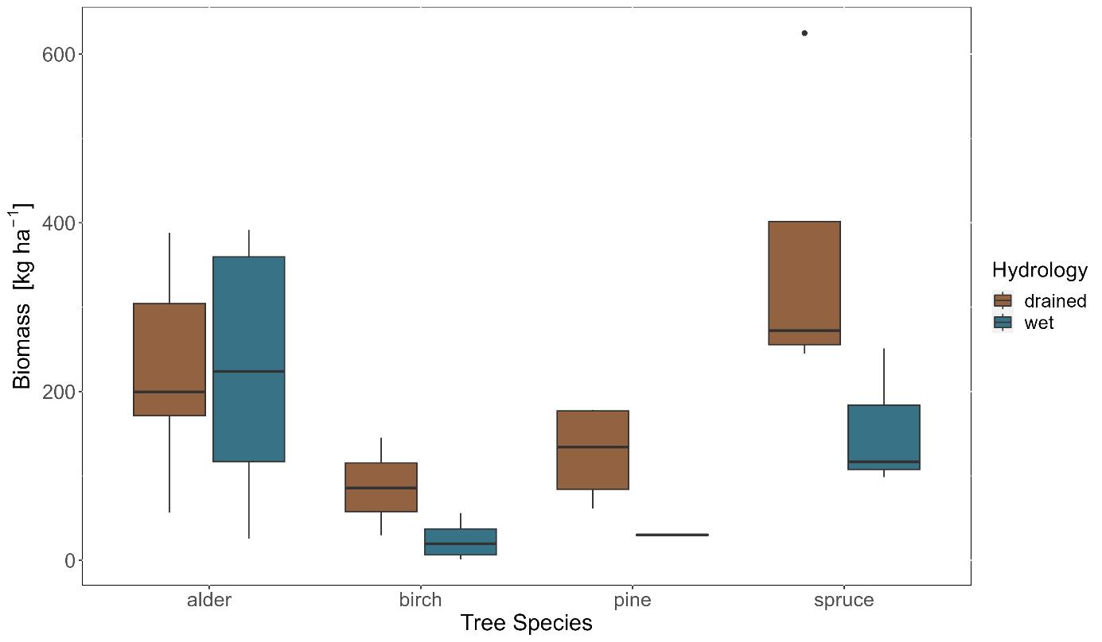

Fig. 4 – Median biomass volume for each hydrological condition grouped by forest stand’s main tree species

The assignment of yield classes to the respective Hg-value for each sample plot depends on the availability of stand age information. For *Alnus glutinosa*, 12 yield classes from 9 sample plots can be determined. The data of birch trees allows to assign 4 yield classes (3 plots) from the yield table of *Betula pubescens* and 5 classes (4 plots) from the one of *B. pendula*. This is due to the narrower range of the yield table of Downy birch which excludes the data of plot 39. 16 yield classes (4 plots) can be derived for *Picea abies* and 6 classes (4 plots) from the yield table of *Pinus sylvestris.*

Alder trees reach a mean yield class of 3.64 with the highest being class 2.50 (Fig. A - 1). Most plots are assigned EKL 4 though because their Hg is still less than what the yield tables lowest class of 3.50 requires. They are performing slightly better on wet terrain where they are classified with a mean yield class of 3.82 compared to 3.40 on drained peatlands (Fig. 5).

Birches’ yield classes depend on the yield table used. Downy birch is classified as 3.06 on average while the same properties for birch equal 2 classes lower in the White birch yield table with a mean of 5.25 (Fig. A - 2). Counted as White birches, they generally achieve the lowest growth rate. When classified as Downy birch, they are ranked slightly higher than alder. Birch shows small insignificant differences between the two types of peatlands (fen and gley soil) and hydrological states (B. pubescens: drained gley soil = 3.00, wet fen = 3.13; B. pendula: drained gley soil = 5.00, wet fen = 5.13). Only one plot on a drained fen shows a bigger, even though insignificant difference at a yield class of 6 when counted as White birch (Fig. 5).

The highest yield classes are reached by pine stands with a mean value of 1.5. The highest class of +0.05 (beyond yield class 0) is assigned for both forest strata of plot 47 (Fig. A - 3) which are located on a wet fen. Nonetheless, the observed pine stands are highly variable in their growth rate among the different peatland types and hydrological conditions (Fig. 5). Pines on drained raised bogs show a lower growth rate with a mean EKL of 2.5. Pine forests on wet bogs are also evaluated with a lower growth rate compared to the drained ones and are assigned a mean EKL of 6 (lower than minimum class of 5). Yet, this difference is not recognized as significant by the applied Dunnet’s test (p = 0.137).

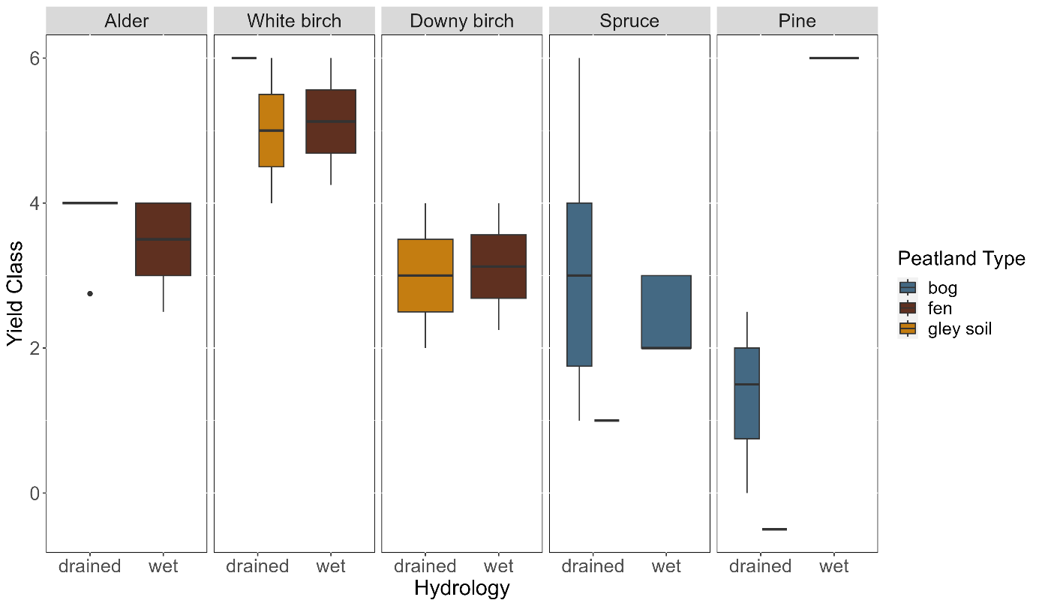

Fig. 5 – Median yield class for each peatland type grouped by hydrology and tree species

Spruce stands do also show a high variation in yield classes (Fig. A - 4). They range from EKL 1 to 6 with a mean of 2.63. Between the site variables peatland type and hydrology, no major differences can be found (Fig. 5). Drained peatlands occur with a mean yield class of 2.78 while spruce stands on wet soils seems to have a slightly higher productivity (EKL 2.43). This difference is not significant. Drained fens show slightly higher growth potential with a yield class of 1 although this does not significantly vary from drained bogs either (p = 0.145). The only significant differences found by Dunnett’s test are between the yield classes of White birch and pine (p = 0.003) and White birch and spruce (p = 0.007).

The Forest Structural Index is composed of several influencing variables (Fig. 6). The highest positive impact on structural diversity originates from the variable of decay classes with a mean value of 0.64 ± 0.35. The peatland sites have mainly low amounts of trees of higher dimensions (Vol40 = 0.08 ± 0.20) and standing deadwood (DWs = 0.23 ± 0.26). The species richness is generally low for both the main forest stand (SR = 0.13 ± 0.23) and the regeneration (SRreg = 0.25 ± 0.24). The other variables achieve medium mean indices but are still below 0.5, which would be half of the maximum value of this particular variable found in this study. The forests on the peatland sites show a higher structural diversity coming from different DBH classes (DBHsd = 0.48 ± 0.23) rather than greater diameters (DBHq = 0.41 ± 0.26). For tree heights a lower variety is found (Hsd = 0.37 ± 0.23) and downed deadwood also only provides a medium mean amount (DWd = 0.42 ± 0.25). No significant differences (p = 0.3778) are found between the SR indices calculated by the data sampled in the general forest inventory and the vegetation survey. Also, the SRreg indices generated from the regeneration survey and the vegetation survey do not differ significantly (p = 0.5408).

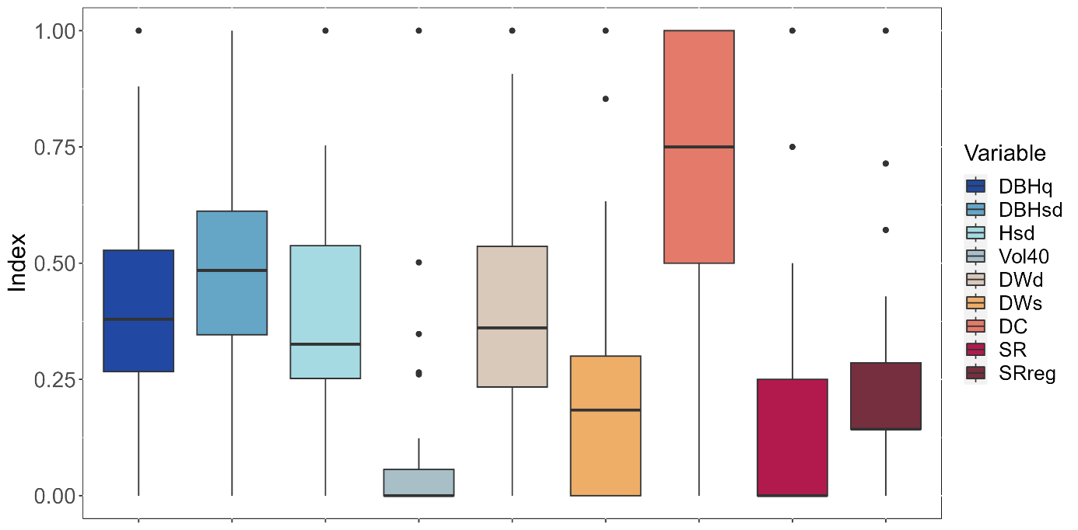

Fig. 6 – Median of variable indices

Forest stands of the four main tree species provide differently pronounced structure indices (Fig. 7). Alder forests offer the highest species richness within the forest stand regeneration (SRreg = 0.36 ± 0.28). Yet, most tree species in the main stand are found in forests dominated by pine trees (SR = 0.33 ± 0.44). The most biomass is currently standing on the plots stocked with spruce (DBHq = 0.61 ± 0.26; Vol40 = 0.27 ± 0.35). Besides a higher variation of tree dimensions (DBHsd = 0.67 ± 0.16; Hsd = 0.50 ± 0.21), spruce forests provide the highest amounts of deadwood (DWd = 0.68 ± 0.20; DWs = 0.31 ± 0.21) with the most diverse range of decay classes as well (DC = 0.81 ± 0.18). Only alder plots show similarly strong structural variables for standing deadwood (DWs = 0.29 ± 0.31) and decay classes (DC = 0.73 ± 0.33), too.

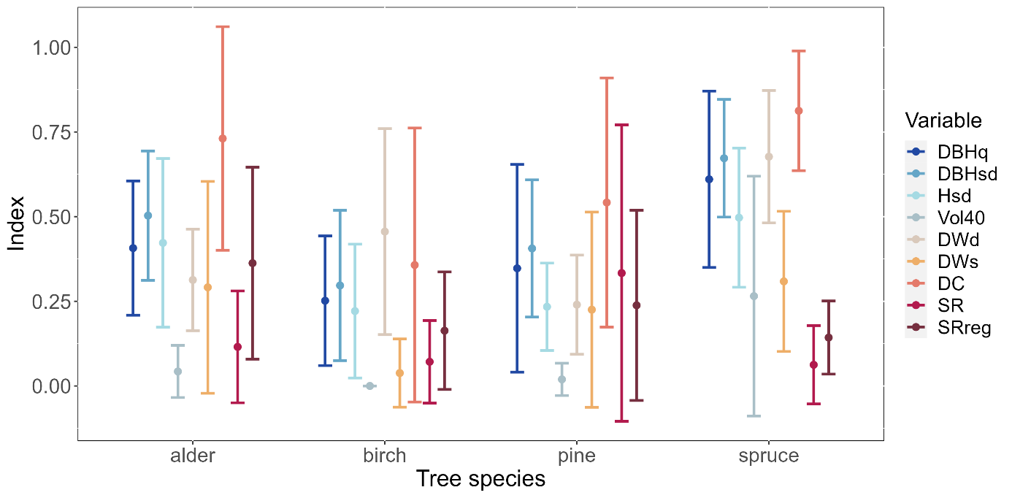

Fig. 7 – Mean values and standard deviation of variables indices for each tree species

Bogs and fens show similar structural properties while generally less structural diverse forests occur on gley soils (Fig. 8). Forests on fens accumulate higher biomasses (DBHq = 0.46 ± 0.26; Vol40 = 0.12 ± 0.24) and more tree species occur in the regeneration layer (SRreg = 0.30 ± 0.28). On raised bogs, a higher species diversity is found in the main forest strata (SR = 0.22 ± 0.38). The variation of different diameters and tree heights is very similar for both bogs (DBHsd = 0.51 ± 0.21; Hsd = 0.38 ± 0.18) and fens (DBHsd = 0.50 ± 0.23; Hsd = 0.39 ± 0.26). Standing deadwood is found more often on fens (DWs = 0.27 ± 0.29) while high amounts of downed deadwood are observed on gley soils (DWd = 0.53 ± 0.34). Both bogs and fens show a high diversity of decay classes (bog: DC = 0.69 ± 0.35; fen: DC = 0.68 ± 0.34).

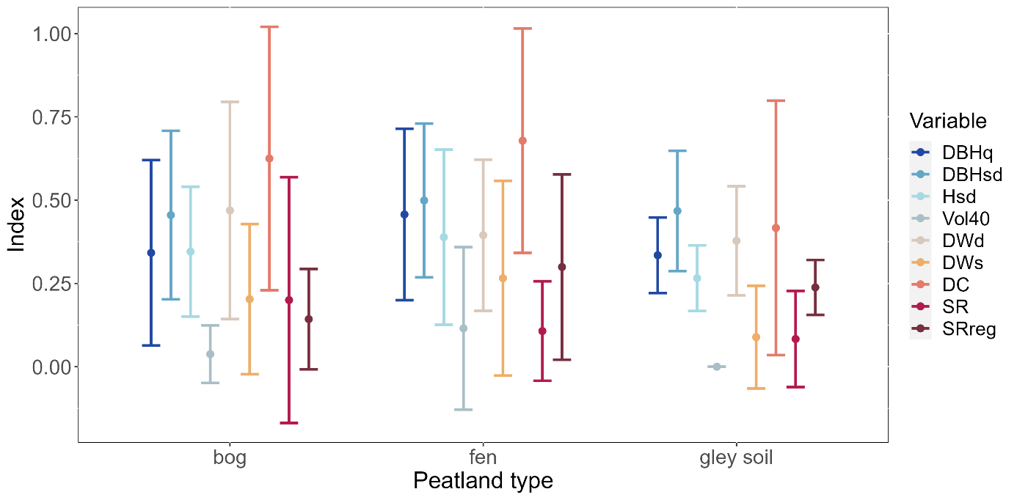

Fig. 8 – Mean values and standard deviation of variables indices for each peatland type

For drained peatland forests higher structural indices are found (Fig. 9). They provide a wider range of tree dimensions (DBHsd = 0.53 ± 0.19; Hsd = 0.38 ± 0.21) and overall, a higher biomass accumulation (DBHq = 0.49 ± 0.26; Vol40 = 0.13 ± 0.25) compared to wet peatlands. While a higher number of different tree species occur the regeneration layer of drained peatlands (SRreg = 0.28 ± 0.25), forests of wet mires are more diverse (SR = 0.15 ± 0.23) than on drained ones. The occurrence of deadwood is similar for both hydrological states (drained: DWd = 0.41 ± 0.25, DWs = 0.24 ± 0.28; wet: DWd = 0.42 ± 0.26, DWs = 0.22 ± 0.26) but the deadwood on drained peatlands shows more different decay classes (DC = 0.68 ± 0.27).

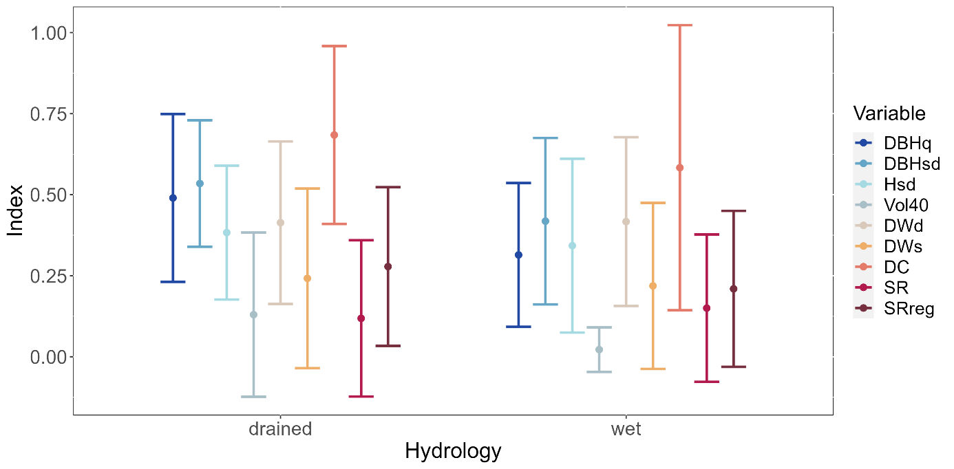

Fig. 9 – Mean values and standard deviation of variables indices for drained and wet peatland sites

The subsequent Forest Structure Index, an index which combines all variable indices, has a mean value of 0.33 ± 0.14. It is the highest in forest stands dominated by spruce (0.45 ± 0.09), followed by deciduous alder forests (0.35 ± 0.12). The lowest FSI is found for birch (0.21 ± 0.11) which shows a significant difference from spruce stands (p = 0.002).

Fig. 10 shows that fens (0.36 ± 0.15) come with a higher structural diversity than bogs (0.31 ± 0.15) and gley soils (0.25 ± 0.05). Coniferous forests especially show a higher structure on fens (pine: 0.36; spruce: 0.49 ± 0.11) compared to bogs (pine: 0.27 ± 0.16; spruce: 0.41 ± 0.07). Gley soils only occurred on birch dominated sample plot. Here they have a higher structural diversity on (0.25 ± 0.05) than on fens (0.19 ± 0.15) or raised bogs (0.12). The differences between the peatland types are not significant.

Fig. 10 – Median Forest Structure Indices for each peatland type grouped by tree species

Peatlands forests tend to develop more structural richness on drained (0.36 ± 0.12) than on wet soils (0.30 ± 0.16) (Fig. 11). In spruce stands the forest structure on drained plots is significantly higher (p = 0.009) than on wet ones. Only alder forests show more structural diversity on more natural and wetter peatlands sites (drained: 0.31 ± 0.10; wet: 0.40 ± 0.14).

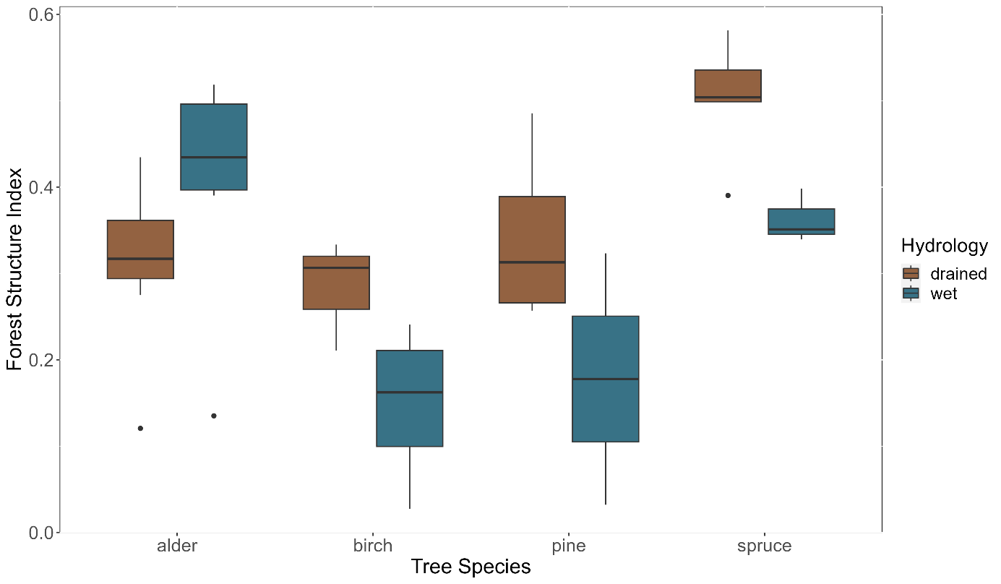

Fig. 11 – Median Forest Structure Indices for each hydrological condition grouped by tree species

The correlation of Forest Structure Index and forest biomass (Fig. 10) show a positive correlation of both parameters. By comparing the R2-value, the exponential regression shows a slightly better fit than the linear one. This and the fact of non-normal distribution of the sampled data justifies the decision for a non-parametric Spearman correlation test over the parametric one from Bravais-Pearson. The subsequent Spearman correlation coefficient ρ = 0.688 identifies a highly positive and significant (p = 1.218*10-5) correlation between the tested parameters and thus approves the assumption from the regression before.

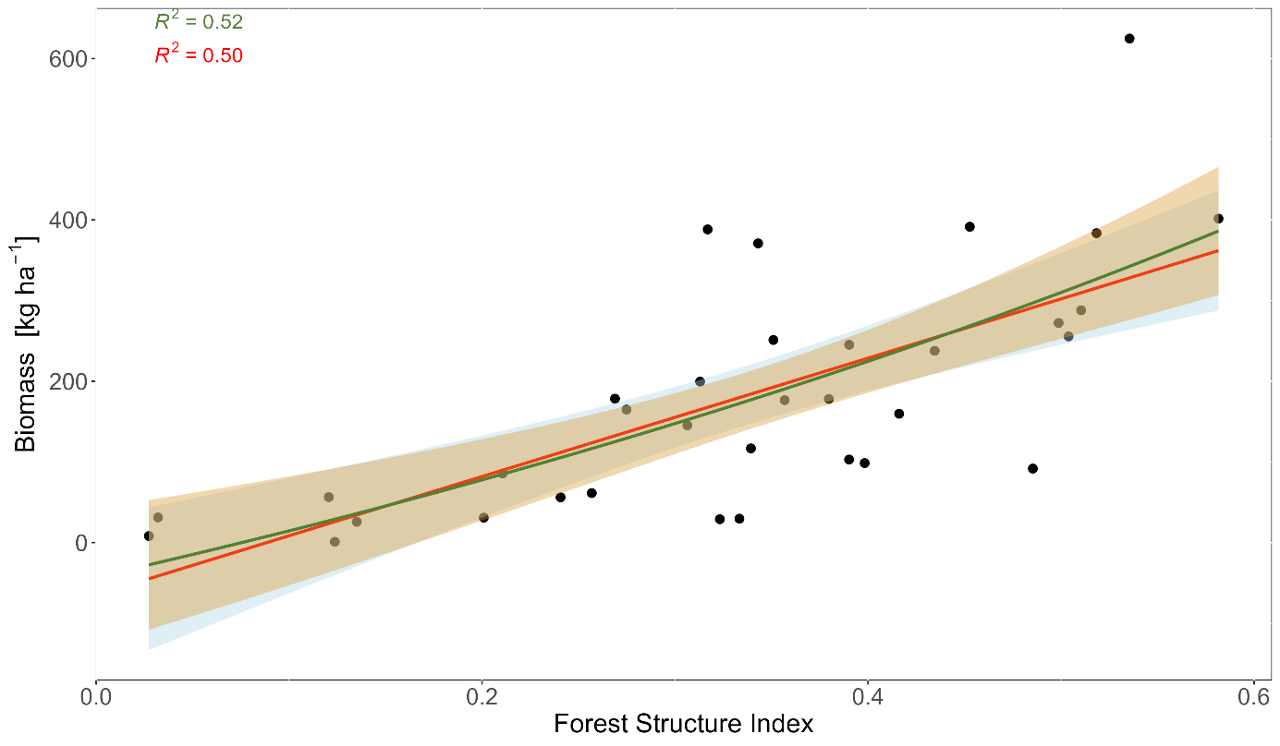

Fig. 12 – Correlation between forest biomass volume and forest structure diversity. The red regression line blue standard error interval indicates a linear relationship and the green graph with the orange SE interval indicates an exponential relation.

# Discussion

# Conclusion

References

Aerts R, Ludwig F (1997) Water-table changes and nutritional status affect trace gas emissions from laboratory columns of peatland soils. Soil Biology and Biochemistry 29:1691–1698. https://www.sciencedirect.com/science/article/pii/S0038071797000746

AG Boden (ed) (2005) Bodenkundliche Kartieranleitung. Mit 103 Tabellen. Schweizerbart, Stuttgart

Albert M, Nagel J, Schmidt M *et al* (2021) Nutzerhinweise zum Geleit: Eine neue Generation von Ertragstafeln für die Baumarten Eiche, Buche, Fichte, Douglasie und Kiefer. Nordwestdeutsche Forstliche Versuchsanstalt. Available via https://www.nw-fva.de/fileadmin/nwfva/common/unterstuetzen/pdf/Nutzerhinweise_zum_Geleit.pdf. Accessed 28 Oct 2023

Ali A, Wang L-Q (2021) Big-sized trees and forest functioning: Current knowledge and future perspectives. Ecological Indicators 127:107760. https://www.sciencedirect.com/science/article/pii/S1470160X21004258

Barbier S, Chevalier R, Loussot P *et al* (2009) Improving biodiversity indicators of sustainable forest management: Tree genus abundance rather than tree genus richness and dominance for understory vegetation in French lowland oak hornbeam forests. Forest Ecology and Management 258:S176-S186. https://www.sciencedirect.com/science/article/pii/S0378112709006331

Barbier S, Gosselin F, Balandier P (2008) Influence of tree species on understory vegetation diversity and mechanisms involved—A critical review for temperate and boreal forests. Forest Ecology and Management 254:1–15. https://www.sciencedirect.com/science/article/pii/S0378112707007025

Bates D, Mächler M, Bolker B *et al* (2015) Fitting Linear Mixed-Effects Models Using lme4. J. Stat. Soft. 67:1–48

Blum WE (2020) Bodenkunde in Stichworten, 7th edn. Schweizerbart Textbooks, Stuttgart

BMUV Nationale Moorschutzstrategie. https://www.bmuv.de/fileadmin/Daten_BMU/Download_PDF/Naturschutz/nationale_moorschutzstrategie_bf.pdf. Accessed 23 Nov 2023

Bolte A, Hertel D, Ammer C *et al* (2003) Freilandmethoden zur Untersuchung von Baumwurzeln. Forstarchiv 74:240–262

Bonn A, Berghöfer A, Couwenberg J *et al* (2015) Klimaschutz durch Wiedervernässung von kohlenstoffreichen Böden. In: Naturkapital Deutschland - TEEB DE (ed) Naturkapital und Klimapolitik - Synergien und Konflikte, 1000th edn. Merkur Druck- und Kopierzentrum GmbH & Co KG, Leipzig, pp 127–147

Braga SR, Oliveira ML de, Gorgens EB (2023a) forestmangr: Forest Mensuration and Management

Braga SR, Oliveira ML de, Gorgens EB (2023b) Fitting linear and non-linear equations by group". Available via https://rdrr.io/cran/forestmangr/f/vignettes/eq_group_fit_en.Rmd. Accessed 20 Sep 2023

Brunialti G, Frati L, Aleffi M *et al* (2010) Lichens and bryophytes as indicators of old‐growth features in Mediterranean forests. Plant Biosystems - An International Journal Dealing with all Aspects of Plant Biology 144:221–233

Burmeister EG, Göttlich K, Grospietsch T *et al* (1990) Begriffsbestimmung anhand der Moortypen Mitteleuropas. In: Göttlich K (ed) Moor- und Torfkunde. Mit 63 Tab. im Text, 3rd edn. Schweizerbart, Hannover, Stuttgart, pp 1–56

Burrascano S, Keeton WS, Sabatini FM *et al* (2013) Commonality and variability in the structural attributes of moist temperate old-growth forests: A global review. Forest Ecology and Management 291:458–479. https://www.sciencedirect.com/science/article/pii/S0378112712006962

Burrascano S, Sabatini FM, Blasi C (2011) Testing indicators of sustainable forest management on understorey composition and diversity in southern Italy through variation partitioning. Plant Ecol 212:829–841. https://link.springer.com/article/10.1007/s11258-010-9866-y

Bütler R, Lachat T, Larrieu L *et al* (2013) Habitat trees: Key elements for forest biodiversity. Integrative Approaches as an Opportunity for the Conservation of Forest Biodiversity. In: Kraus D, Krumm F (eds) Integrative approaches as an opportunity for the conservation of forest biodiversity. European Forest Institute, [Joensuu]

Castagneri D, Garbarino M, Berretti R *et al* (2010) Site and stand effects on coarse woody debris in montane mixed forests of Eastern Italian Alps. Forest Ecology and Management 260:1592–1598. https://www.sciencedirect.com/science/article/pii/S0378112710004548

Clymo RS (1984) Sphagnum-Dominated Peat Bog. A Naturally Acid Ecosystem. Philosophical Transactions of the Royal Society of London:487–499. http://research.sbcs.qmul.ac.uk/r.clymo/Clymo-article-PDFs/26-Clymo-1984-Natural-acidity.pdf

Curtis RO (1967) Height-Diameter and Height-Diameter-Age Equations For Second-Growth Douglas-Fir. for sci 13:365–375

Curtis RO, Marshall DD (2000) Technical Note: Why Quadratic Mean Diameter? Western Journal of Applied Forestry:137–139. https://www.fs.usda.gov/pnw/olympia/silv/publications/opt/436_CurtisMarshall2000.pdf

Dahm S (2006) Auswertungsalgorithmen für die zweite Bundeswaldinventur. Bundesforschungsanstalt für Forst- und Holzwirtschaft Hamburg, Eberswalde

Drexhage M, Colin F (2001) Estimating root system biomass from breast-height diameters. Forestry: An International Journal of Forest Research 74:491–497

DWS (2022) Moore, Auen, Sümpfe. Warum Feuchtgebiete so wichtig für den Natur- und Artenschutz sind. Available via https://www.deutschewildtierstiftung.de/aktuelles/moor-aue-sumpf. Accessed 16 Oct 2023

Eggelsmann R (1990a) Moor und Wasser. In: Göttlich K (ed) Moor- und Torfkunde. Mit 63 Tab. im Text, 3rd edn. Schweizerbart, Hannover, Stuttgart, pp 288–319

Eggelsmann R (1990b) Ökohydrologie und Moorschutz. In: Göttlich K (ed) Moor- und Torfkunde. Mit 63 Tab. im Text, 3rd edn. Schweizerbart, Hannover, Stuttgart, pp 357–373

Eggelsmann R, Mäkelä T (1964) Einfluss von Entwässerung und landwirtschaftlicher Nutzung auf die Durchlässigkeit des Moorbodens. AFSci 36:77–84

Fox J, Weisberg S (2019) An R Companion to Applied Regression. Sage, Thousand Oaks

Gabriel M, Pfaffner N, Gärtner J *et al* Methodenhandbuch für den Aufbau eines deutschlandweiten Moorbodenmonitorings für den Klimaschutz (MoMoK)- Teil 2: Wald. Thünen Working Paper, 1st edn., Eberswalde

GADM (2022) Germany, 4th edn.

Gadow K von (2003) Waldstruktur und Wachstum. Beilage zur Vorlesung im Wintersemester 2003 / 2004. Reihe der Universitätsdrucke Göttingen. http://webdoc.sub.gwdg.de/ebook/y/2003/gadow/gadow_waldwachstum_2003.pdf

Gärtner A, Jönsson AM, Metcalfe DB *et al* (2023) Temperature and Tree Size Explain the Mean Time to Fall of Dead Standing Trees across Large Scales. Forests 14:1017

Gilhen-Baker M, Roviello V, Beresford-Kroeger D *et al* (2022) Old growth forests and large old trees as critical organisms connecting ecosystems and human health. A review. Environ Chem Lett 20:1529–1538. https://link.springer.com/article/10.1007/s10311-021-01372-y

Göttlich, K (ed) (1990) Moor- und Torfkunde. Mit 63 Tab. im Text. Schweizerbart, Hannover, Stuttgart

Grützmacher F, Schulte-Eickholt A (2017) Entwicklung und Schutz unserer Moore. Zum Nutzen vn Mensch, Natur und Klima. Naturschutzbund Deutschland e.V. Available via https://www.nabu.de/imperia/md/content/nabude/naturschutz/moorschutz/190502-broschuere-moorschutz-2017.pdf. Accessed 6 Nov 2023

Haglöf Vertex 5, Långsele. https://haglofsweden.com/wp-content/uploads/2021/02/Vertex-5-ENU_s.pdf. Accessed 6 Nov 2023

Hao Z, Zhang J, Song B *et al* (2007) Vertical structure and spatial associations of dominant tree species in an old-growth temperate forest. Forest Ecology and Management 252:1–11. https://www.sciencedirect.com/science/article/pii/S0378112707004392

Hasch B, Meier R, Luthardt V *et al* (2007) Renaturierung von Waldmooren in Brandenburg und erste Ergebnisse zum Aufbau eines Entscheidungsunterstützungssystems für das Management von Waldmooren. Telma:165–183. https://e-docs.geo-leo.de/bitstream/handle/11858/7346/TELMA%2037%20%282007%29%20Hasch%20et%20al.pdf?sequence=1&isAllowed=y

Hatanaka N, Wright W, Loyn RH *et al* (2011) ‘Ecologically complex carbon’- linking biodiversity values, carbon storage and habitat structure in some austral temperate forests. Global Ecology and Biogeography 20:260–271. https://onlinelibrary.wiley.com/doi/10.1111/j.1466-8238.2010.00591.x

Hoover CM, Leak WB, Keel BG (2012) Benchmark carbon stocks from old-growth forests in northern New England, USA. Forest Ecology and Management 266:108–114. https://www.sciencedirect.com/science/article/pii/S0378112711006864

Höper H (2007) Freisetzung von Treibhausgasen aus deutschen Mooren

Hothorn T, Bretz F, Westfall P (2008) Simultaneous Inference in General Parametric Models. Biometrical Journal:346–363

Houghton RA (2005) Aboveground Forest Biomass and the Global Carbon Balance. Global Change Biology 11:945–958

Hutchinson JN (1980) The Record of Peat Wastage in the East Anglian Fenlands at Holme Post, 1848-1978 A.D. The Journal of Ecology 68:229

IUCN Peatland Programme (2023) Peatland Damage. Available via https://www.iucn-uk-peatlandprogramme.org/about-peatlands/peatland-damage. Accessed 19 Oct 2023

IUCN UK (2020) What's so special about peatlands? The truth behind the bog. IUCN UK - Peatland Programme. Available via https://www.iucn-uk-peatlandprogramme.org/sites/default/files/2019-06/Peatland_Leaflet_ONLINE_V2.pdf. Accessed 3 Jun 2023

Johansen OM, Andersen DK, Ejrnæs R *et al* (2018) Relations between vegetation and water level in groundwater dependent terrestrial ecosystems (GWDTEs). Limnologica 68:130–141. https://www.sciencedirect.com/science/article/pii/S0075951117300452

Johansson T, Hjelm B (2012) Stump and Root Biomass of Poplar Stands. Forests 3:166–178

Johnson CW (1985) Bogs of the Northeast. University Press of New England, Hanover / London

Joosten H (1993) Denken wie ein Hochmoor: Hydrologische Selbstregulation von Hochmooren und deren Bedeutung für Wiedervernässung und Restauration. Berichte der Deutschen Gesellschaft für Moor- und Torfkunde

Joosten J, Clarke D (2002) Wise use of mires and peatlands. Background and principles including a framework for decision-making. International Mire Conservation Group; International Peat Society, [S.l.], [Jyväskylä]

Juchheim J, Ehbrecht M, Schall P *et al* (2019) Effect of tree species mixing on stand structural complexity. Forestry: An International Journal of Forest Research

Kändler G, Bosch B (2013) Methodenentwicklung für die 3. Bundeswaldinventur. Modul 3 Überprüfung und Neukonzeption einer Biomassefunktion. Abschlussbericht

Kaule G (1973) Die Vegetation der Moore im Hinteren Bayerischen Wald

Keeton WS (2006) Managing for late-successional/old-growth characteristics in northern hardwood-conifer forests. Forest Ecology and Management 235:129–142. https://www.sciencedirect.com/science/article/pii/S0378112706005214

Kramer H, Akça A (2002) Leitfaden zur Waldmeßlehre, 4th edn. Sauerländer, Frankfurt am Main

Lassauce A, Paillet Y, Jactel H *et al* (2011) Deadwood as a surrogate for forest biodiversity: Meta-analysis of correlations between deadwood volume and species richness of saproxylic organisms. Ecological Indicators 11:1027–1039. https://www.sciencedirect.com/science/article/pii/S1470160X11000380

Lembcke G, Dittmar O, Knapp E Ertragstafel für die Kiefer (Pinus sylvestris, L.) im norddeutschen Tiefland. Landesforstanstalt Eberswalde, Eberswalde. https://forst.brandenburg.de/sixcms/media.php/9/kieferetk.pdf. Accessed 20 Jul 2023

Li C, Grayson R, Holden J *et al* (2018) Erosion in peatlands: Recent research progress and future directions. Earth-Science Reviews 185:870–886. https://www.sciencedirect.com/science/article/pii/S0012825218300576

Lockow K-W Ertragstafel für die Roterle (Alnus glutinosa (L.) Gaertn.) im nordostdeutschen Tiefland. Forstliche Forschungsanstalt Eberswalde, Eberswalde. https://forst.brandenburg.de/sixcms/media.php/9/Roterle_ET.pdf. Accessed 20 Jul 2023

Lockow K-W Ertragstafel für die Moorbirke (Betula pubescens Ehrh.) in Nordostdeutschland. Forstliche Forschungsanstalt Eberswalde, Eberswalde. https://forst.brandenburg.de/sixcms/media.php/9/Moorbirke_ET.pdf. Accessed 20 Jul 2023

Lockow K-W Ertragstafel für die Sandbirke (Betula pendula Roth) in Nordostdeutschland. Forstliche Forschungsanstalt Eberswalde, Eberswalde. https://forst.brandenburg.de/sixcms/media.php/9/Sandbirke_ET.pdf. Accessed 20 Jul 2023

Lombardi F, COCOZZA C, LASSERRE B *et al* (2011) Dendrochronological assessment of the time since death of dead wood in an old growth Magellan's beech forest, Navarino Island (Chile). Austral Ecology 36:329–340

Martins AC, Willig MR, Presley SJ *et al* (2017) Effects of forest height and vertical complexity on abundance and biodiversity of bats in Amazonia. Forest Ecology and Management 391:427–435. https://www.sciencedirect.com/science/article/pii/S0378112717302761

Matsuo T, Hiura T, Onoda Y (2022) Vertical and horizontal light heterogeneity along gradients of secondary succession in cool- and warm-temperate forests. Journal of vegetation science : official organ of the International Association for Vegetation Science 33:e13135

Müller-Kroehling S, Riegert F, Hertel M *et al* (2023) Ultimativer Kohlenstoffspeicher: Klimaschutz braucht Moorwälder. Bayerisches Landwirtschaftliches Wochenblatt. https://www.wochenblatt-dlv.de/feld-stall/wald/ultimativer-kohlenstoffspeicher-klimaschutz-braucht-moorwaelder-574840

Müller-Kroehling S, Zollner A (2015) Moorschutz im Wald - gestern, heute, morgen. Moor und Wald schließen sich keineswegs aus. Und: Moorwälder sind ganz besonders schützenswerte Landschaftselemente. LWF aktuell:21–25. https://www.researchgate.net/profile/Stefan-Mueller-Kroehling/publication/325545647_Moorschutz_im_Wald_-_gestern_heute_morgen/links/5b6d54bd45851546c9f9bbf4/Moorschutz-im-Wald-gestern-heute-morgen.pdf

NABU (2023) Moore in Deutschland. Available via https://www.nabu.de/natur-und-landschaft/moore/deutschland/index.html. Accessed 18 Oct 2023

Neubauer M, Demant B (2016) Wurzeln als Kohlenstoffspeicher: Untersuchungen zur unterirdischen Biomasse von Birke, Eiche und Kiefer. Universitätsdruckerei Freiburg, Freiburg im Breisgau

Neuwirth E (2022) RColorBrewer: ColorBrewer Palettes

Norris C, Hobson P, Ibisch PL (2012) Microclimate and vegetation function as indicators of forest thermodynamic efficiency. Journal of Applied Ecology 49:562–570

Ogle DH, Doll JC, Wheeler AP *et al* (2023) FSA: Simple Fisheries Stock Assessment Methods

Pan Y, Birdsey RA, Fang J *et al* (2011) A large and persistent carbon sink in the world's forests. Science (New York, N.Y.) 333:988–993

Pedersen TL (2023) patchwork: The Composer of Plots

Persiani AM, Audisio P, Lunghini D *et al* (2010) Linking taxonomical and functional biodiversity of saproxylic fungi and beetles in broad‐leaved forests in southern Italy with varying management histories. Plant Biosystems - An International Journal Dealing with all Aspects of Plant Biology 144:250–261

Pickert E, Bräutigam T (2017) Bodenregion der Altmoränenlandschaften - Niedermoore. LfULG Sachsen, Dresden

Prescott CE (2002) The influence of the forest canopy on nutrient cycling. Tree physiology 22:1193–1200

QGIS Development Team (2023) QGIS Geographic Information System. QGIS Association

R Core Team (2023) R: A Language and Environment for Statistical Computing. R Foundation for Statistical Computing, Vienna

Ramchunder SJ, Brown LE, Holden J (2009) Environmental effects of drainage, drain-blocking and prescribed vegetation burning in UK upland peatlands. Progress in Physical Geography: Earth and Environment 33:49–79

Rattay M, Sengbusch P von, Konold W (2016) Die ökologischen Auswirkungen der Grabenverschließungen im Eschengrundmoos (Gemeinde Hinterzarten). Moorkundliche Untersuchung der ältesten Wiedervernässungsmaßnahme im Schwarzwald. Berichte der Naturforschenden Gesellschaft zu Freiburg. https://www.zobodat.at/pdf/Berichte-naturf-Ges-Freiburg-Br_106_0129-0172.pdf

Riedel T, Hennig P, Kroiher F *et al* (2017) Die dritte Bundeswaldinventur (BWI 2012). Inventur- und Auswertungsmethoden. Bundesministerium für Ernährung und Landwirtschaft, Eberswalde

Roulet NT, Moore TR (1995) The effect of forestry drainage practices on the emission of methane from northern peatlands. Can. J. For. Res. 25:491–499

RStudio Team (2023) RStudio: Integrated Development Environment for R. RStudio, PBC, Boston, MA

Sabatini FM, Burrascano S, Lombardi F *et al* (2015) An index of structural complexity for Apennine beech forests. iForest 8:314–323

Sauerbrey R, Lehrkamp H, Holz C (2002) Zum Wandel der Bodenform in den Niedermoorgebieten Brandenburgs durch langjährige Nutzung. Telma:199–206. https://e-docs.geo-leo.de/bitstream/handle/11858/7194/Sauerbrey%2c%20R.pdf?sequence=1&isAllowed=y

Schober R (1995) Ertragstafeln wichtiger Baumarten bei verschiedener Durchforstung, 4th edn. Sauerländer, Frankfurt am Main

Schrautzer J, Trepel M Niedermoore im Östlichen Hügelland. Tuexenia Beiheft, Göttingen. https://www.researchgate.net/profile/Michael-Trepel/publication/265702714_Niedermoore_im_Ostlichen_Hugelland/links/549fe5510cf257a635fe8dc9/Niedermoore-im-Oestlichen-Huegelland.pdf. Accessed 5 Nov 2023

Sloboda J, Gaffrey D, Matsumura N (1993) Regionale und lokale Systeme von Höhenkurven gleichartiger Waldbestände. Allgemeine Forst und Jagdzeitung 12:225–228

Stegink-Hindriks L (2022) Forstwirtschaftliche Nutzung. MoorIS. Available via https://mooris-niedersachsen.de/?pgId=27. Accessed 23 Nov 2023

Stephenson NL, Das AJ, Condit R *et al* (2014) Rate of tree carbon accumulation increases continuously with tree size. Nature 507:90–93. https://www.nature.com/articles/nature12914

Storch F, Boch S, Gossner MM *et al* (2023) Linking structure and species richness to support forest biodiversity monitoring at large scales. Annals of Forest Science 80

Storch F, Dormann CF, Bauhus J (2018) Quantifying forest structural diversity based on large-scale inventory data: a new approach to support biodiversity monitoring. Forest Ecosystems 5

Succow M, Jeschke L (2022) Deutschlands Moore. Ihr Schicksal in unserer Kulturlandschaft. Natur+Text, Rangsdorf

Thünen-Institut (2012) Dritte Bundeswaldinventur - Ergebnisdatenbank. 5.02 Zuwachs des Vorrates [m³/ha*a] nach Land und Baumartengruppe. Thünen-Institut für Waldökosysteme. Available via https://bwi.info/

UN WFP (2019) World Administrative Boundaries. World Food Programme (UN Agency)

van Laar A, Akça A (2007) Growth And Yield. In: van Laar A, Akça A (eds) Forest mensuration, 2nd edn. Springer, Dordrecht, pp 201–227

Vonderach C, Kublin E, Kändler G (2023) TapeS: Tree Taper Curves and Sorting Based on 'TapeR'

Weis W, Kölling C, Schäff T (2016) Kronennutzung aus nährstoffkundlicher Siche. LWF aktuell:16–19. https://www.lwf.bayern.de/mam/cms04/boden-klima/dateien/a108_kronennutzung_aus_naehrstoffkundlicher_sicht_gesch.pdf

Wellbrock N, Makowski V, Bielefeldt J *et al* (2022) Arbeitsanleitung für die dritte Bodenzustandserhebung im Wald (BZE III). Thünen Working Paper. https://literatur.thuenen.de/digbib_extern/dn064965.pdf

Wende G, Schlenz S (2017) "Seilakt" im Moorwald. Seilbahnbringung bringt Waldnutzung und Waldnaturschutz auf sensiblen Moorstandorten unter einen Hut. LWF aktuell:42–44. https://www.lwf.bayern.de/mam/cms04/forsttechnik-holz/dateien/a115_schlenz_moorwald.pdf

Wickham H (2016) ggplot2: Elegant Graphics for Data Analytics. Springer, New York

Xintu L (2009) Conditions of Peat Formation. In: Jinsheng G (ed) Coal, Oil Shale, Natural Bitumen, Heavy Oil and Peat. EOLSS Publications, pp 298–308

Xu J, Morris PJ, Liu J *et al* (2018) PEATMAP: Refining estimates of global peatland distribution based on a meta-analysis. CATENA 160:134–140

Yu Z, Loisel J, Brosseau DP *et al* (2010) Global peatland dynamics since the Last Glacial Maximum. Geophys. Res. Lett. 37:n/a-n/a

Zollner A (1993) Renaturierung von bewaldeten Mooren im Oberbayerischen Staatswald

Zollner A, Cronauer H (1998) Wiedervernässung und Durchforstung als Maßnahmen zur Renaturierung bewaldeter Moore in Bayern. erste Versuchsergebnisse. Laufener Spezialbeiträge und Laufener Seminararbeitsräge (LSB):55–64. https://www.zobodat.at/pdf/Laufener-Spez-u-Seminarbeitr_6_1998_0055-0064.pdf

Figures

Fig. 1 – Monitoring sites across Germany. The Map was created in QGIS (QGIS Development Team (QGIS Development Team 2023)) using open source data from GADM (2022) and UN WFP (2019) 15

Fig. 2 – Plot design: Squared sampling plot (edge length: 50.00 m) with a circular forest inventory plot (radius: 12.62 m) and 4 satellite circular plots for the natural regeneration survey (radius: 5.00 m) 17

Fig. 3 – Median biomass volume for each peatland type grouped by forest stand’s main tree species 28

Fig. 4 – Median biomass volume for each hydrological condition grouped by forest stand’s main tree species 29

Fig. 5 – Median yield class for each peatland type grouped by hydrology and tree species 30

Fig. 6 – Median of variable indices 31

Fig. 7 – Mean values and standard deviation of variables indices for each tree species 32

Fig. 8 – Mean values and standard deviation of variables indices for each peatland type 33

Fig. 9 – Mean values and standard deviation of variables indices for drained and wet peatland sites 33

Fig. 10 – Median Forest Structure Indices for each peatland type grouped by tree species 34

Fig. 11 – Median Forest Structure Indices for each hydrological condition grouped by tree species 35

Fig. 12 – Correlation between forest biomass volume and forest structure diversity. The red regression line blue standard error interval indicates a linear relationship and the green graph with the orange SE interval indicates an exponential relation. 36

Figures (Appendix)

Fig. A - 1 – Yield classes for Alnus glutinosa XX

Fig. A - 2 – Yield classes for Betula pubescens (left) and Betula pendula (right) XX

Fig. A - 3 – Yield classes for Pinus sylvestris XXI

Fig. A - 4 – Yield classes for Picea abies XXI

Tables

Tab. 1 – Age determination (Wellbrock et al. 2022) 17

Tab. 2 – Deadwood types (Wellbrock et al. 2022) 18

Tab. 3 – Degree of decay (Wellbrock et al. 2022) 18

Tab. 4 – forest strata (Wellbrock et al. 2022) 19

Tab. 5 – Measurement tools and analysis software 19

Tab. 6 – species related curve-fitting coefficients for SLOBODA height curves (Dahm 2006) 21

Tab. 7 – Species related curve fitting coefficients for CURTIS height curves 21

Tab. 8 – Species related coefficients for the above-ground biomass function of trees with a DBH ≥ 10 cm (Kändler and Bosch 2013) 22

Tab. 9 – Species related coefficients for the above-ground biomass function of trees with a DBH < 10 cm and a height ≥ 1.3 m 23

Tab. 10 – Species related coefficients for the above-ground biomass function of trees with a height < 1.3 m 23

Tab. 11 – Species related coefficients for the below-ground biomass functions 23

Tables (Appendix)

Tab. A - 1 – Description of the sample plots XVIII

Tab. A - 2 – Biomass and Forest Structural Index results per plot XXII

Appendix

1. Sampling plots

Tab. A - 1 – Description of the sample plots

| Site ID | Region | Site name | Peatland type | Hydrological condition | Forest type |
| --- | --- | --- | --- | --- | --- |
| 1 | Brandenburg | Stromtrasse/Spechthausen | fen | not drained | birch |
| 2 | Brandenburg | Buxpfuhl/Melchow | fen | drained | alder |
| 3 | Brandenburg | Postluch/Britz | fen | not drained | alder |
| 4 | Brandenburg | Plötzensee/Biesenthal | fen | drained | birch |
| 5 | Brandenburg | Hellsee/Biesenthal | fen | not drained (revived) | alder |
| 6 | Brandenburg | Pfauenfließ/Biesenthal | fen | not drained (raised water level) | alder |
| 8 | Baden-Württemberg | Hockenheimer Rheinbogen | fen | drained | alder |
| 19 | Bavaria | Filzwald/Klingbrunn Bhf | bog | not drained | spruce |
| 20 | Bavaria | Klosterfilz/Skt. Oswald | bog | not drained | pine |
| 24 | Hesse | Brander Bruch/Münden | gley soil | drained | birch |
| 25 | Hesse | Ellerhorst/Münden | fen | not drained | alder |
| 26 | Hesse | Krämersgrund/Wetter | fen | drained | alder |
| 27 | Mecklenburg Western Pomerania | Pälitzsee/Pelzkuhl | fen | drained | alder |
| 29 | Mecklenburg Western Pomerania | Drewensee/Priepert | fen | drained | alder |
| 30 | Mecklenburg Western Pomerania | Rätzsee/Fleeth | fen | not drained | alder |
| 31 | Mecklenburg Western Pomerania | Buchenhorst | fen | drained | alder |
| 33 | Lower Saxony | Wildenkiel 1 | fen | drained | spruce |
| 34 | Lower Saxony | Wildenkiel 2 | gley soil | drained | birch |
| 37 | Lower Saxony | Großes Moor bei Malloh | bog | drained | pine |
| 38 | Lower Saxony | Brambosteler Moor | fen | drained | pine |
| 39 | Lower Saxony | Wildenloh | bog | drained | pine |
| 40 | Lower Saxony | Holzurburg | bog | drained | pine |
| 46 | North Rhine Westphalia | Ebbemoor | gley soil | not drained | birch |
| 47 | Rhineland-Palatinate | Landstuhler Bruch | fen | drained | spruce |
| 48 | Rhineland-Palatinate | Palmbruch/Morbach | bog (transition bog) | not drained | birch |
| 49 | Schleswig-Holstein | Krummsee | fen | not drained | alder |
| 50 | Schleswig-Holstein | Schwonau | fen | drained | alder |
| 51 | Saxony Anhalt | Jävenitzer Moor/Gardelegen | fen | not drained | birch |
| 52 | Thuringia | Siegmundsburg | fen | drained | spruce |
| 55 | Thuringia | Sommerbachskopf 2 | fen | not drained | spruce |
| 56 | Saxony | Gr. Eisenstraßenmoor/ Johanngeorgenstadt | bog | drained | spruce |
| 57 | Saxony | Friedrichsheider Hochmoor/ Erlabrunn | bog | not drained | pine |
| 59 | Saxony | Steinbach/Steinbach | bog | drained | spruce |
| 60 | Saxony | Milchbach/Erlabrunn | bog | drained | spruce |

1. Yield class graphics

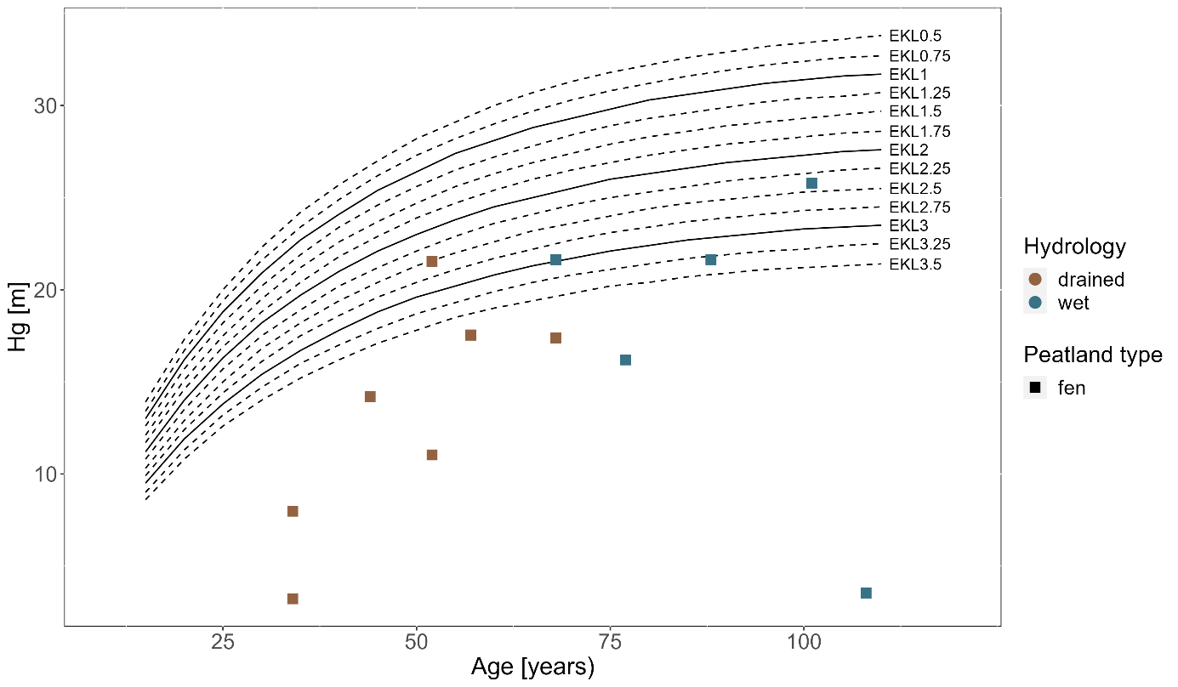

Fig. A - 1 – Yield classes for Alnus glutinosa

Fig. A - 2 – Yield classes for Betula pubescens (left) and Betula pendula (right)

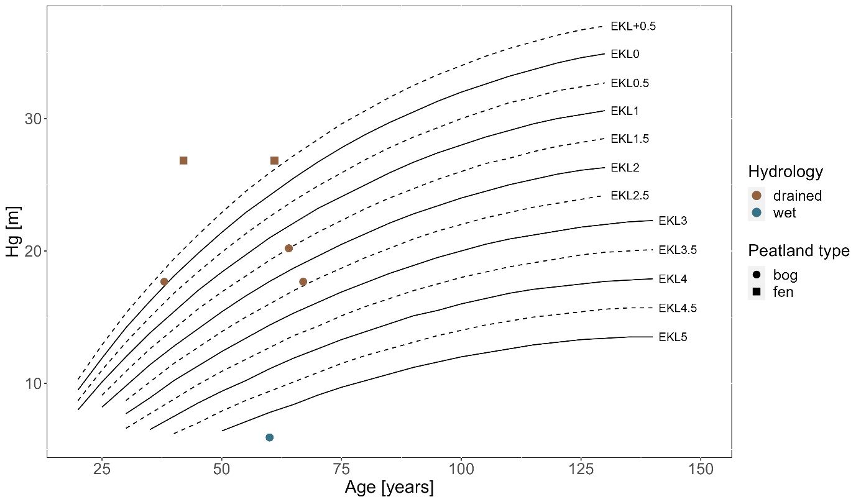

Fig. A - 3 – Yield classes for Pinus sylvestris

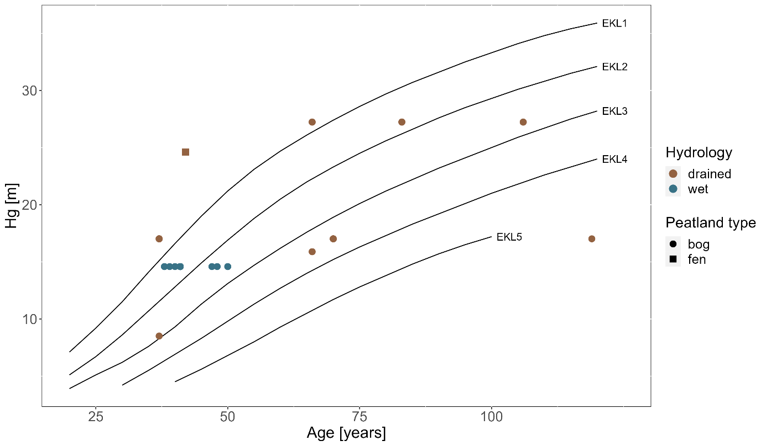

Fig. A - 4 – Yield classes for Picea abies

1. Plots’ results

Tab. A - 2 – Biomass and Forest Structural Index results per plot

| Site ID | Biomass [kg ha-1] | DBHq | DBHsd | Vol40 | Hsd | DWd | DWs | DC | SRreg | SR | FSI |
| --- | --- | --- | --- | --- | --- | --- | --- | --- | --- | --- | --- |
| 1 | 8.13 | 0 | 0.07 | 0 | 0 | 0.17 | 0 | 0 | 0 | 0 | 0.03 |
| 2 | 199.56 | 0.31 | 0.50 | 0.06 | 0.47 | 0.34 | 0 | 1.00 | 0.14 | 0 | 0.31 |
| 3 | 383.49 | 0.76 | 1.00 | 0.27 | 1.00 | 0.50 | 0 | 0.75 | 0.14 | 0.25 | 0.52 |
| 4 | 29.66 | 0.19 | 0.35 | 0 | 0.57 | 0.21 | 0 | 1.00 | 0.43 | 0.25 | 0.33 |
| 5 | 391.51 | 0.53 | 0.54 | 0 | 0.44 | 0.26 | 0.33 | 1.00 | 0.71 | 0.25 | 0.45 |
| 6 | 25.73 | 0.11 | 0.22 | 0 | 0.26 | 0.16 | 0.21 | 0.25 | 0 | 0 | 0.14 |
| 8 | 164.90 | 0.31 | 0.43 | 0 | 0.32 | 0.38 | 0 | 0.50 | 0.29 | 0.25 | 0.27 |
| 19 | 98.55 | 0.43 | 0.65 | 0 | 0.56 | 0.32 | 0.62 | 1.00 | 0 | 0 | 0.40 |
| 20 | 29.01 | 0.08 | 0.28 | 0 | 0.30 | 0.17 | 0.18 | 1.00 | 0.14 | 0.75 | 0.32 |
| 24 | 145.33 | 0.47 | 0.57 | 0 | 0.36 | 0.20 | 0.27 | 0.75 | 0.14 | 0 | 0.31 |
| 25 | 102.91 | 0.28 | 0.44 | 0 | 0.36 | 0.45 | 0.16 | 1.00 | 0.57 | 0.25 | 0.39 |
| 26 | 388.22 | 0.52 | 0.57 | 0.06 | 0 | 0.54 | 0.23 | 0.50 | 0.43 | 0 | 0.32 |
| 27 | 56.38 | 0.18 | 0.28 | 0 | 0.35 | 0 | 0.13 | 0 | 0.14 | 0 | 0.12 |
| 29 | 370.86 | 0.39 | 0.36 | 0 | 0.60 | 0.16 | 0.29 | 1.00 | 0.29 | 0 | 0.34 |
| 30 | 159.69 | 0.47 | 0.61 | 0.05 | 0.75 | 0.38 | 0.44 | 0.75 | 0.29 | 0 | 0.42 |
| 31 | 177.99 | 0.27 | 0.44 | 0 | 0.29 | 0.29 | 0.13 | 1.00 | 1.00 | 0 | 0.38 |
| 33 | 624.76 | 1.00 | 0.68 | 1.00 | 0.22 | 0.73 | 0.30 | 0.75 | 0.14 | 0 | 0.54 |
| 34 | 85.64 | 0.27 | 0.26 | 0 | 0.17 | 0.42 | 0 | 0.50 | 0.29 | 0 | 0.21 |
| 37 | 178.36 | 0.81 | 0.49 | 0.12 | 0.33 | 0.43 | 0 | 0.25 | 0 | 0 | 0.27 |
| 38 | 176.56 | 0.62 | 0.38 | 0 | 0.07 | 0.29 | 0.63 | 0.50 | 0.71 | 0 | 0.36 |
| 39 | 91.72 | 0.32 | 0.76 | 0 | 0.35 | 0.22 | 0.53 | 0.75 | 0.43 | 1.00 | 0.49 |
| 40 | 61.37 | 0.22 | 0.34 | 0 | 0.28 | 0.33 | 0 | 0.75 | 0.14 | 0.25 | 0.26 |
| 46 | 56.04 | 0.27 | 0.57 | 0 | 0.27 | 0.52 | 0 | 0 | 0.29 | 0.25 | 0.24 |
| 47 | 401.54 | 0.65 | 0.99 | 0.50 | 0.75 | 0.51 | 0.59 | 1.00 | 0 | 0.25 | 0.58 |
| 48 | 1.01 | 0.06 | 0 | 0 | 0.06 | 1.00 | 0 | 0 | 0 | 0 | 0.12 |
| 49 | 287.94 | 0.42 | 0.53 | 0 | 0.38 | 0.34 | 0.85 | 1.00 | 0.57 | 0.50 | 0.51 |
| 50 | 237.68 | 0.75 | 0.62 | 0.12 | 0.26 | 0.26 | 1.00 | 0.75 | 0.14 | 0 | 0.43 |
| 51 | 30.94 | 0.51 | 0.25 | 0 | 0.12 | 0.67 | 0 | 0.25 | 0 | 0 | 0.20 |
| 52 | 272.23 | 0.88 | 0.78 | 0.35 | 0.69 | 0.91 | 0 | 0.50 | 0.14 | 0.25 | 0.50 |
| 55 | 116.72 | 0.46 | 0.44 | 0.01 | 0.25 | 0.73 | 0.27 | 0.75 | 0.14 | 0 | 0.34 |
| 56 | 251.12 | 0.30 | 0.48 | 0 | 0.31 | 0.57 | 0.21 | 1.00 | 0.29 | 0 | 0.35 |
| 57 | 31.16 | 0.04 | 0.18 | 0 | 0.07 | 0 | 0 | 0 | 0 | 0 | 0.03 |
| 59 | 245.18 | 0.36 | 0.61 | 0 | 0.61 | 0.85 | 0.18 | 0.75 | 0.14 | 0 | 0.39 |
| 60 | 255.56 | 0.80 | 0.76 | 0.26 | 0.58 | 0.80 | 0.30 | 0.75 | 0.29 | 0 | 0.50 |